# Mobile Application Development Assignment 2

Name: Sanket Khule Div: A

Roll No: 51

1. Write an android code to make phone call using Intent

Ans:

Java:

**package** com.example.callingapp;  
  
**import** androidx.appcompat.app.AppCompatActivity;  
**import** androidx.core.app.ActivityCompat;  
  
**import** android.Manifest;  
**import** android.content.Intent;  
**import** android.content.pm.PackageManager;  
**import** android.net.Uri;  
**import** android.os.Bundle;  
**import** android.view.View;  
**import** android.widget.Button;  
**import** android.widget.EditText;  
**import** android.widget.Toast;  
  
**public class** MainActivity **extends** AppCompatActivity {  
 EditText **txt_phoneNumber**;  
 Button **btn_call**;  
 @Override  
 **protected void** onCreate(Bundle savedInstanceState) {  
 **super**.onCreate(savedInstanceState);  
 setContentView(R.layout.***activity_main***);  
 **txt_phoneNumber** = (EditText) findViewById(R.id.***txt_number***);  
 **btn_call** = (Button) findViewById(R.id.***btn_call***);  
  
  
 **btn_call**.setOnClickListener(**new** View.OnClickListener() {  
 @Override  
 **public void** onClick(View view) {  
 Intent intentCall = **new** Intent(Intent.***ACTION_CALL***);  
 String number = **txt_phoneNumber**.getText().toString();  
 **if** (number.trim().isEmpty()) {  
  
 Toast.*makeText*(MainActivity.**this**, **"Please enter Your Phone Number"**, Toast.***LENGTH_SHORT***);  
  
 } **else** {  
 intentCall.setData(Uri.*parse*(**"tel:"** + number));  
 }  
 **if** (ActivityCompat.*checkSelfPermission*(getApplicationContext(), Manifest.permission.***CALL_PHONE***) != PackageManager.***PERMISSION_GRANTED***) {  
 Toast.*makeText*(MainActivity.**this**, **"Please Grant Permission"**, Toast.***LENGTH_LONG***).show();  
 } **else** {  
 startActivity(intentCall);  
 }  
  
  
 }  
  
  
 });  
 }  
 **private void** requestPermission(){  
 ActivityCompat.*requestPermissions*(MainActivity.**this**,**new** String[]{Manifest.permission.***CALL_PHONE***}, 1);  
  
 }  
  
}

Xml:

*<?***xml version="1.0" encoding="utf-8"***?>*<**RelativeLayout xmlns:android="http://schemas.android.com/apk/res/android"  
 xmlns:app="http://schemas.android.com/apk/res-auto"  
 xmlns:tools="http://schemas.android.com/tools"  
 android:layout_width="match_parent"  
 android:layout_height="match_parent"  
 android:icon="@drawable/ic_call_"  
 android:background="@drawable/call"  
 android:padding="30dp"  
  
 tools:context=".MainActivity"**>  
  
 <**EditText  
 android:layout_marginTop="50dp"  
 android:layout_width="match_parent"  
 android:layout_height="wrap_content"  
 android:hint="Whom You Want To Call?"  
  
 android:id="@+id/txt_number"  
 android:inputType="phone"** />  
 <**Button  
 android:layout_width="match_parent"  
 android:layout_height="wrap_content"  
 android:id="@+id/btn_call"  
 android:text="Call At Your Own Risk"  
 android:textSize="20sp"  
 android:textColor="#ffffff"  
 android:layout_marginTop="100dp"**/>  
</**RelativeLayout**>

Output:

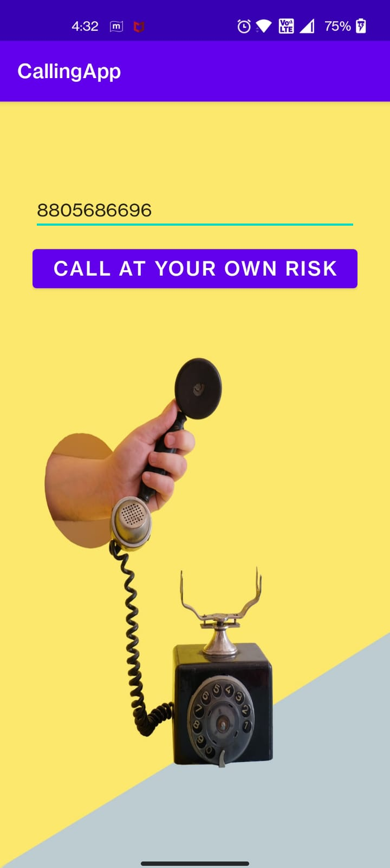

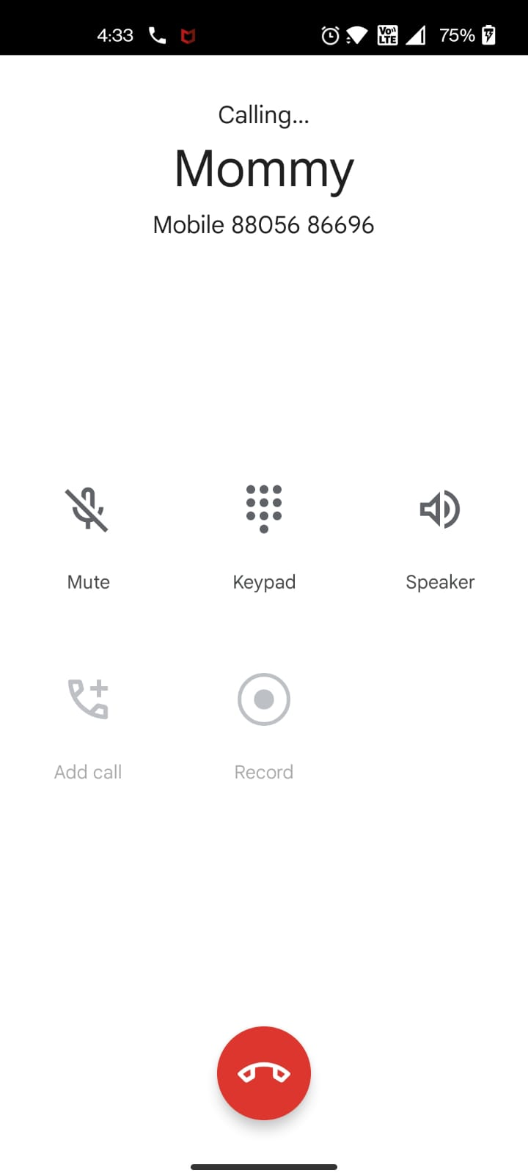

1. Write an android code to turn ON/OFF Bluetooth

Ans:

Java:

**package** com.example.bluetooth;  
  
**import** android.os.Bundle;  
**import** android.app.Activity;  
**import** android.view.Menu;  
**import** android.bluetooth.BluetoothAdapter;  
**import** android.content.Intent;  
**import** android.view.View;  
**import** android.widget.Button;  
**import** android.widget.TextView;  
**import** android.widget.Toast;  
  
**public class** MainActivity1 **extends** Activity {  
 **private static final int *REQUEST_ENABLE_BT*** = 0;  
 **private static final int *REQUEST_DISCOVERABLE_BT*** = 0;  
 @Override  
 **protected void** onCreate(Bundle savedInstanceState) {  
 **super**.onCreate(savedInstanceState);  
 setContentView(R.layout.***activity_main1***);  
 **final** TextView out=(TextView)findViewById(R.id.***out***);  
 **final** Button button1 = (Button) findViewById(R.id.***button1***);  
 **final** Button button3 = (Button) findViewById(R.id.***button2***);  
 **final** BluetoothAdapter mBluetoothAdapter = BluetoothAdapter.*getDefaultAdapter*();  
 **if** (mBluetoothAdapter == **null**) {  
 out.setText(**"DEVICE NOT SUPPORTED"**);  
 }  
 button1.setOnClickListener(**new** View.OnClickListener() {  
 **public void** onClick(View v) {  
 **if** (!mBluetoothAdapter.isEnabled()) {  
 Intent enableBtIntent = **new** Intent(BluetoothAdapter.***ACTION_REQUEST_ENABLE***);  
 startActivityForResult(enableBtIntent, ***REQUEST_ENABLE_BT***);  
 out.setText(**"BLUETOOTH ON"**);  
 }  
 }  
 });  
 button1.setOnClickListener(**new** View.OnClickListener() {  
 @Override  
 **public void** onClick(View arg0) {  
 **if** (!mBluetoothAdapter.isDiscovering()) {  
 out.setText(**"BLUETOOTH ON Holla Amigos!!!"**);  
  
 Intent enableBtIntent = **new** Intent(BluetoothAdapter.***ACTION_REQUEST_DISCOVERABLE***);  
 startActivityForResult(enableBtIntent, ***REQUEST_DISCOVERABLE_BT***);  
  
 }  
 }  
 });  
 button3.setOnClickListener(**new** View.OnClickListener() {  
 @Override  
 **public void** onClick(View arg0) {  
 mBluetoothAdapter.disable();  
 out.setText(**"BLUETOOTH OFF Adios Amigos!!!"**);  
 Toast.*makeText*(getApplicationContext(), **"Adios Amigos"**, Toast.***LENGTH_LONG***);  
  
 }  
 });  
 }  
  
 @Override  
 **public boolean** onCreateOptionsMenu(Menu menu) {  
 *// Inflate the menu; this adds items to the action bar if it is present.* getMenuInflater().inflate(R.menu.***activity_main***, menu);  
 **return true**;  
 }  
  
}

Xml:

*<?***xml version="1.0" encoding="utf-8"***?>*<**androidx.constraintlayout.widget.ConstraintLayout xmlns:android="http://schemas.android.com/apk/res/android"  
 xmlns:app="http://schemas.android.com/apk/res-auto"  
 xmlns:tools="http://schemas.android.com/tools"  
 android:layout_width="match_parent"  
 android:layout_height="match_parent"  
 tools:context=".MainActivity1"**>  
  
  
 <**Button  
 android:id="@+id/button1"  
 android:layout_width="wrap_content"  
 android:layout_height="wrap_content"  
 android:backgroundTint="#75DC71"  
 android:hapticFeedbackEnabled="false"  
 android:text="ON"  
 android:textColor="#050505"  
 app:layout_constraintBottom_toBottomOf="parent"  
 app:layout_constraintEnd_toEndOf="parent"  
 app:layout_constraintHorizontal_bias="0.241"  
 app:layout_constraintStart_toStartOf="parent"  
 app:layout_constraintTop_toTopOf="parent"  
 app:layout_constraintVertical_bias="0.572"** />  
  
 <**Button  
 android:id="@+id/button2"  
 android:layout_width="wrap_content"  
 android:layout_height="wrap_content"  
 android:backgroundTint="#F15F5F"  
 android:text="OFF"  
 android:textColor="#090808"  
 app:layout_constraintBottom_toBottomOf="parent"  
 app:layout_constraintEnd_toEndOf="parent"  
 app:layout_constraintHorizontal_bias="0.755"  
 app:layout_constraintStart_toStartOf="parent"  
 app:layout_constraintTop_toTopOf="parent"  
 app:layout_constraintVertical_bias="0.572"** />  
  
 <**TextView  
 android:id="@+id/out"  
 android:layout_width="309dp"  
 android:layout_height="132dp"  
 android:background="#FCFAF9"  
 android:gravity="center_horizontal"  
 android:textColor="#3F51B5"  
 android:textSize="34sp"  
 android:textStyle="bold"  
 app:layout_constraintBottom_toBottomOf="parent"  
 app:layout_constraintEnd_toEndOf="parent"  
 app:layout_constraintStart_toStartOf="parent"  
 app:layout_constraintTop_toTopOf="parent"  
 app:layout_constraintVertical_bias="0.292"** />  
  
  
</**androidx.constraintlayout.widget.ConstraintLayout**>

Output:

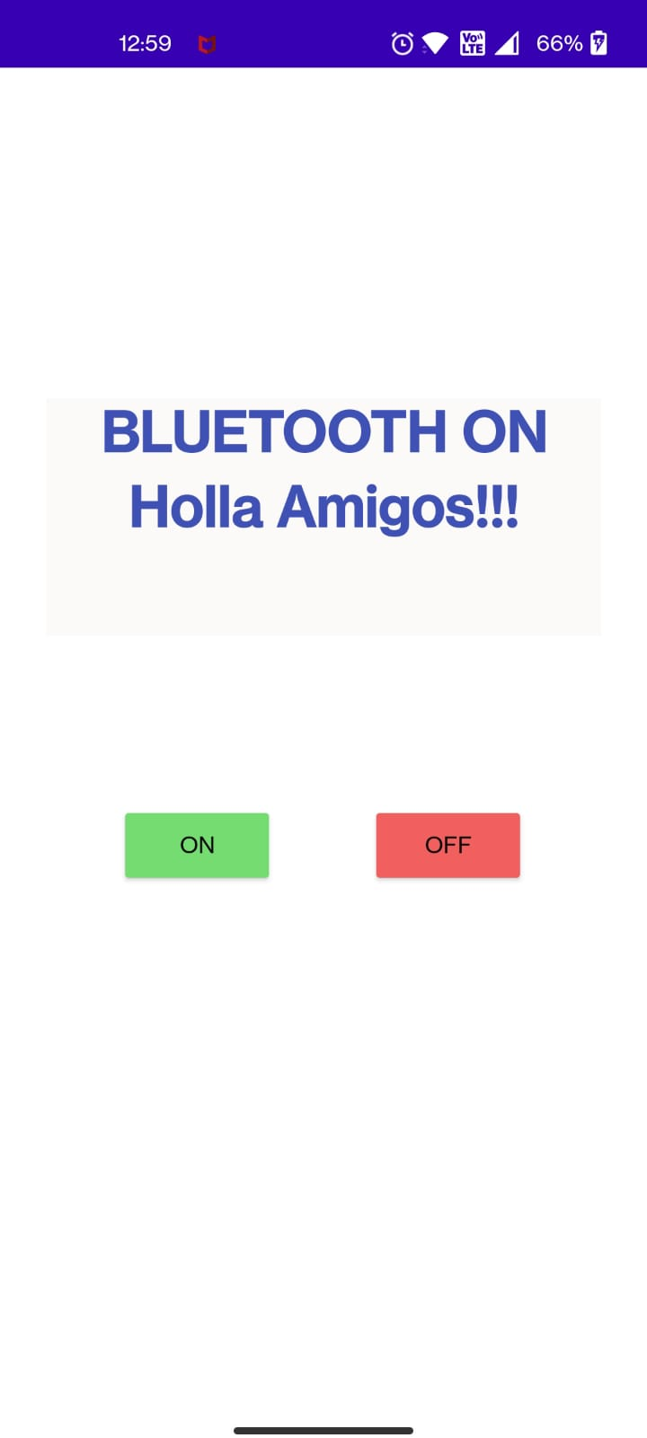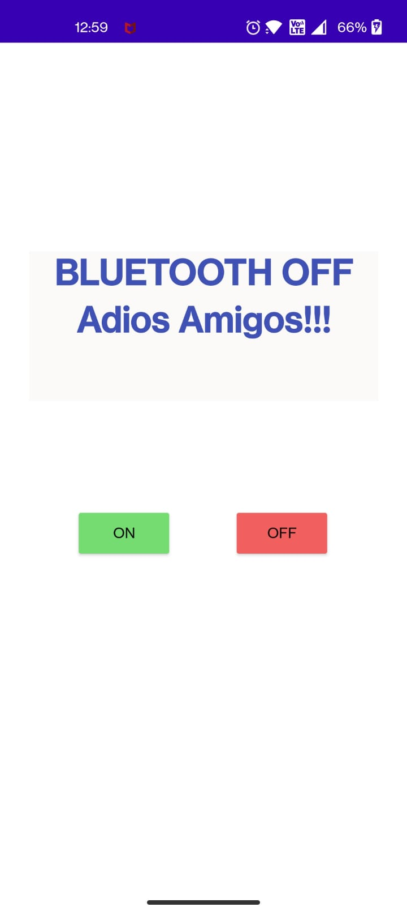

1. Write an android code to turn ON /OFF the Wi-Fi

Ans:

Java:

**package** com.example.wifi;  
  
  
**import** android.net.wifi.WifiManager;  
**import** android.os.Bundle;  
**import** android.app.Activity;  
**import** android.content.Context;  
**import** android.view.View;  
**import** android.view.View.OnClickListener;  
**import** android.widget.Button;  
**import** android.widget.TextView;  
  
**import** androidx.appcompat.app.AppCompatActivity;  
  
**public class** MainActivity **extends** AppCompatActivity {  
 Button **enableButton**,**disableButton**;  
 TextView **txt**;  
 **private** WifiManager **wifiManager**;  
 @Override  
 **protected void** onCreate(Bundle savedInstanceState) {  
 **super**.onCreate(savedInstanceState);  
 setContentView(R.layout.***activity_main***);  
 **wifiManager**=(WifiManager) getApplicationContext().getSystemService(Context.***WIFI_SERVICE***);  
 **enableButton**=(Button)findViewById(R.id.***button1***);  
 **disableButton**=(Button)findViewById(R.id.***button2***);  
 **txt**=findViewById(R.id.***txt***);  
 **enableButton**.setOnClickListener(**new** OnClickListener(){  
 **public void** onClick(View v){  
 **if**(!**wifiManager**.isWifiEnabled()) {  
 **wifiManager**.setWifiEnabled(**true**);  
 **txt**.setText(**"WIFI ON"**);  
 }  
 }  
 });  
  
 **disableButton**.setOnClickListener(**new** OnClickListener(){  
 **public void** onClick(View v){  
 **if**(**wifiManager**.isWifiEnabled()) {  
 **wifiManager**.setWifiEnabled(**false**);  
 **txt**.setText(**"WIFI OFF"**);  
 }  
 }  
 });  
 }  
  
}

Xml:

*<?***xml version="1.0" encoding="utf-8"***?>*<**androidx.constraintlayout.widget.ConstraintLayout xmlns:android="http://schemas.android.com/apk/res/android"  
 xmlns:app="http://schemas.android.com/apk/res-auto"  
 xmlns:tools="http://schemas.android.com/tools"  
 android:layout_width="match_parent"  
 android:layout_height="match_parent"  
 tools:context=".MainActivity"**>  
  
 <**Button  
 android:id="@+id/button1"  
 android:layout_width="wrap_content"  
 android:layout_height="wrap_content"  
  
 android:layout_centerVertical="true"  
 android:layout_marginBottom="84dp"  
 android:background="#7FEC84"  
 android:text="Enable Wifi"  
 app:layout_constraintBottom_toTopOf="@+id/button2"  
 app:layout_constraintEnd_toEndOf="parent"  
 app:layout_constraintHorizontal_bias="0.492"  
 app:layout_constraintStart_toStartOf="parent"** />  
  
 <**Button  
 android:id="@+id/button2"  
 android:layout_width="wrap_content"  
 android:layout_height="wrap_content"  
  
 android:layout_alignParentBottom="true"  
 android:layout_marginBottom="84dp"  
 android:background="#F6EBCA"  
 android:text="Disable Wifi"  
 app:layout_constraintBottom_toBottomOf="parent"  
 app:layout_constraintEnd_toEndOf="parent"  
 app:layout_constraintHorizontal_bias="0.483"  
 app:layout_constraintStart_toStartOf="parent"** />  
  
 <**TextView  
 android:id="@+id/txt"  
 android:layout_width="309dp"  
 android:layout_height="63dp"  
 android:gravity="center"  
 android:textSize="16sp"  
 android:textStyle="bold"  
 app:layout_constraintBottom_toBottomOf="parent"  
 app:layout_constraintEnd_toEndOf="parent"  
 app:layout_constraintStart_toStartOf="parent"  
 app:layout_constraintTop_toTopOf="parent"  
 app:layout_constraintVertical_bias="0.236"** />  
  
</**androidx.constraintlayout.widget.ConstraintLayout**>

Output:

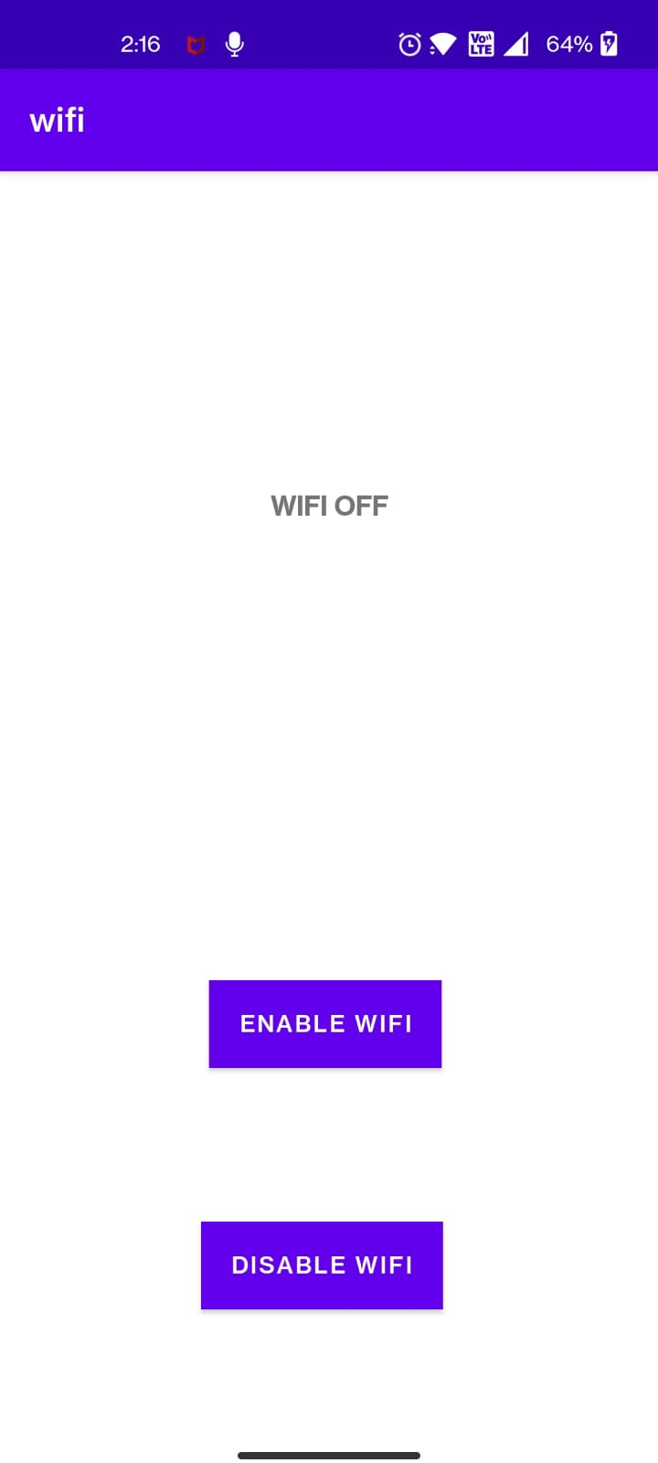

1. Design android application for login activity. Write android code to check login credentials with username = "mca" and password = "android". Display appropriate toast message to the user.

Ans:

Java:

**package** com.example.login;  
  
**import** androidx.appcompat.app.AppCompatActivity;  
  
**import** android.content.Intent;  
**import** android.os.Bundle;  
**import** android.text.method.PasswordTransformationMethod;  
**import** android.view.View;  
**import** android.widget.Button;  
**import** android.widget.EditText;  
**import** android.widget.TextView;  
**import** android.widget.Toast;  
  
**public class** MainActivity **extends** AppCompatActivity {  
 Button **btn**;  
 TextView **txt**;  
 EditText **ed1**,**ed2**;  
 String **s1**,**s2**,**s3**,**s4**;  
 @Override  
 **protected void** onCreate(Bundle savedInstanceState) {  
 **super**.onCreate(savedInstanceState);  
 setContentView(R.layout.***activity_main***);  
 **btn**=findViewById(R.id.***button1***);  
 **txt**=findViewById(R.id.***textView3***);  
 **ed1**=findViewById(R.id.***ed1***);  
 **ed2**=findViewById(R.id.***ed2***);  
 **btn**.setOnClickListener(**new** View.OnClickListener() {  
 @Override  
 **public void** onClick(View view) {  
 **s1**=**"mca"**;  
 **s2**=**"android"**;  
 **s3**=**ed1**.getText().toString();  
 **s4**=**ed2**.getText().toString();  
 **if** (**s1**.equals(**s3**) && **s2**.equals(**s4**))  
 {  
 Toast.*makeText*(getApplicationContext(),**"Login Successful"**,Toast.***LENGTH_LONG***).show();  
  
 }  
 **else** {  
 Toast.*makeText*(getApplicationContext(),**"Invalid Credential."**,Toast.***LENGTH_LONG***).show();  
 }  
  
 }  
 });  
 **txt**.setOnClickListener(**new** View.OnClickListener() {  
 @Override  
 **public void** onClick(View view) {  
 **if**(**txt**.getText().toString().equals(**"Show Password"**)){  
 **txt**.setText(**"Hide Password"**);  
 **ed2**.setTransformationMethod(**null**);  
 } **else** {  
 **txt**.setText(**"Show Password"**);  
 **ed2**.setTransformationMethod(**new** PasswordTransformationMethod());  
 }  
 }  
 });  
  
  
  
 }  
}

Xml:

*<?***xml version="1.0" encoding="utf-8"***?>*<**androidx.constraintlayout.widget.ConstraintLayout xmlns:android="http://schemas.android.com/apk/res/android"  
 xmlns:app="http://schemas.android.com/apk/res-auto"  
 xmlns:tools="http://schemas.android.com/tools"  
 android:layout_width="match_parent"  
 android:layout_height="match_parent"  
 android:background="@drawable/sec"  
 android:theme="@style/ThemeOverlay.AppCompat.ActionBar"  
 tools:context=".MainActivity"**>  
  
 <**Button  
 android:id="@+id/button1"  
 android:layout_width="138dp"  
 android:layout_height="49dp"  
 android:text="LOGIN"  
 android:textSize="20sp"  
 android:textStyle="bold"  
 app:layout_constraintBottom_toBottomOf="parent"  
 app:layout_constraintEnd_toEndOf="parent"  
 app:layout_constraintHorizontal_bias="0.498"  
 app:layout_constraintStart_toStartOf="parent"  
 app:layout_constraintTop_toTopOf="parent"  
 app:layout_constraintVertical_bias="0.684"** />  
  
 <**TextView  
 android:id="@+id/textView1"  
 android:layout_width="133dp"  
 android:layout_height="47dp"  
 android:background="#F1B1E4"  
 android:fontFamily="@font/aclonica"  
 android:gravity="center"  
 android:text="USERNAME"  
 android:textColor="#F80909"  
 android:textSize="16sp"  
 app:layout_constraintBottom_toBottomOf="parent"  
 app:layout_constraintEnd_toEndOf="parent"  
 app:layout_constraintHorizontal_bias="0.057"  
 app:layout_constraintStart_toStartOf="parent"  
 app:layout_constraintTop_toTopOf="parent"  
 app:layout_constraintVertical_bias="0.366"  
 tools:ignore="TextContrastCheck"** />  
  
 <**TextView  
 android:id="@+id/textView2"  
 android:layout_width="133dp"  
 android:layout_height="47dp"  
 android:background="#F6B7F0"  
 android:fontFamily="@font/aclonica"  
 android:gravity="center"  
 android:text="PASSWORD"  
 android:textColor="#F80909"  
 android:textSize="16sp"  
 app:layout_constraintBottom_toBottomOf="parent"  
 app:layout_constraintEnd_toEndOf="parent"  
 app:layout_constraintHorizontal_bias="0.057"  
 app:layout_constraintStart_toStartOf="parent"  
 app:layout_constraintTop_toTopOf="parent"  
 app:layout_constraintVertical_bias="0.517"  
 tools:ignore="TextContrastCheck"** />  
  
 <**EditText  
 android:id="@+id/ed1"  
 android:layout_width="wrap_content"  
 android:layout_height="wrap_content"  
 android:background="@color/purple_200"  
 android:ems="10"  
 android:inputType="text"  
 android:minHeight="48dp"  
 app:layout_constraintBottom_toBottomOf="parent"  
 app:layout_constraintEnd_toEndOf="parent"  
 app:layout_constraintHorizontal_bias="0.92"  
 app:layout_constraintStart_toStartOf="parent"  
 app:layout_constraintTop_toTopOf="parent"  
 app:layout_constraintVertical_bias="0.367"  
 tools:ignore="SpeakableTextPresentCheck"** />  
  
 <**EditText  
 android:id="@+id/ed2"  
 android:layout_width="208dp"  
 android:layout_height="49dp"  
 android:background="@color/purple_200"  
 android:ems="10"  
 android:inputType="textPassword"  
 app:layout_constraintBottom_toBottomOf="parent"  
 app:layout_constraintEnd_toEndOf="parent"  
 app:layout_constraintHorizontal_bias="0.926"  
 app:layout_constraintStart_toStartOf="parent"  
 app:layout_constraintTop_toTopOf="parent"  
 app:layout_constraintVertical_bias="0.519"  
 tools:ignore="SpeakableTextPresentCheck,TouchTargetSizeCheck"** />  
  
 <**TextView  
 android:id="@+id/textView3"  
 android:layout_width="145dp"  
 android:layout_height="38dp"  
 android:background="#FFFFFF"  
 android:gravity="center"  
 android:text="Show Password"  
 android:textColor="#39683B"  
 android:textSize="16sp"  
 android:textStyle="bold|italic"  
 app:layout_constraintBottom_toBottomOf="parent"  
 app:layout_constraintEnd_toEndOf="parent"  
 app:layout_constraintHorizontal_bias="0.939"  
 app:layout_constraintStart_toStartOf="parent"  
 app:layout_constraintTop_toTopOf="parent"  
 app:layout_constraintVertical_bias="0.594"** />  
  
 <**TextView  
 android:id="@+id/textView"  
 android:layout_width="488dp"  
 android:layout_height="73dp"  
 android:background="#E4E8E8"  
 android:fontFamily="@font/holtwood_one_sc"  
 android:gravity="center"  
 android:text=" LOGIN "  
 android:textColor="#E36E15"  
 android:textSize="34sp"  
 android:textStyle="bold"  
 app:layout_constraintBottom_toBottomOf="parent"  
 app:layout_constraintEnd_toEndOf="parent"  
 app:layout_constraintHorizontal_bias="1.0"  
 app:layout_constraintStart_toStartOf="parent"  
 app:layout_constraintTop_toTopOf="parent"  
 app:layout_constraintVertical_bias="0.024"** />  
</**androidx.constraintlayout.widget.ConstraintLayout**>

Output:

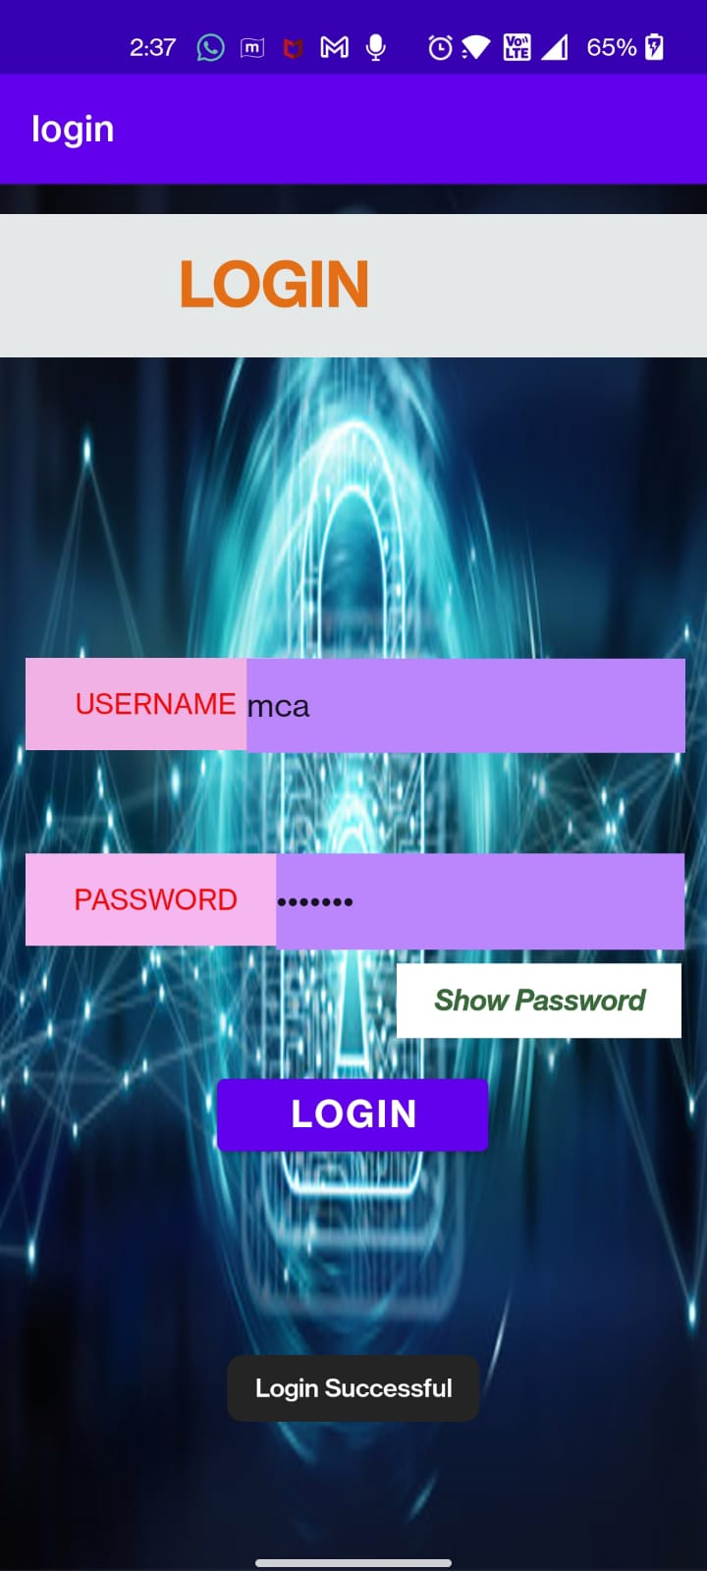

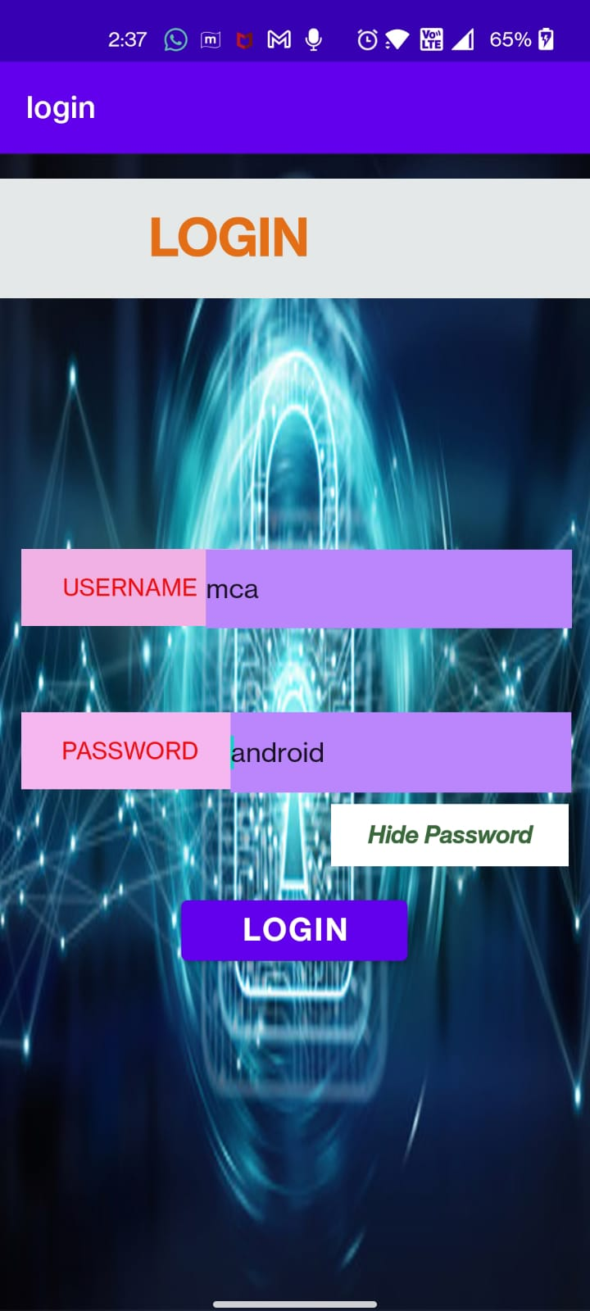

1. Create a fragment that has its own UI and enable your activities to communicate with fragments.

Ans:

Java:

**package** com.example.fragment;  
  
**import** androidx.appcompat.app.AppCompatActivity;  
**import** androidx.fragment.app.Fragment;  
  
**import** android.os.Bundle;  
**import** android.view.View;  
  
**public class** MainActivity **extends** AppCompatActivity {  
  
 *// creating object for Fragment* Fragment **selectedFragment**;  
  
 @Override  
 **protected void** onCreate(Bundle savedInstanceState) {  
 **super**.onCreate(savedInstanceState);  
 setContentView(R.layout.***activity_main***);  
 }  
  
 *// method for displaying the appropriate  
 // fragment according to the clicked button* **public void** selectFragment(View view) {  
  
 **if** (view == findViewById(R.id.***button1***)) {  
 **selectedFragment** = **new** FirstFragment();  
 } **else** {  
 **selectedFragment** = **new** SecondFragment();  
 }  
  
 getSupportFragmentManager()  
 .beginTransaction()  
 .replace(R.id.***fragment_container***, **selectedFragment**)  
 .commit();  
 }  
}

FirstFragment:

**package** com.example.fragment;  
  
**import** android.os.Bundle;  
**import** android.view.LayoutInflater;  
**import** android.view.View;  
**import** android.view.ViewGroup;  
  
**import** androidx.annotation.NonNull;  
**import** androidx.annotation.Nullable;  
**import** androidx.fragment.app.Fragment;  
  
**public class** FirstFragment **extends** Fragment {  
 @Nullable  
 @Override  
 **public** View onCreateView(@NonNull LayoutInflater inflater, @Nullable ViewGroup  
 container, @Nullable Bundle savedInstanceState) {  
 *//return super.onCreateView(inflater, container, savedInstanceState);* **return** inflater.inflate(R.layout.***first_fragment***,container,**false**);  
 }  
}

SecondFragment:

**package** com.example.fragment;  
  
**import** android.os.Bundle;  
**import** android.view.LayoutInflater;  
**import** android.view.View;  
**import** android.view.ViewGroup;  
  
**import** androidx.annotation.NonNull;  
**import** androidx.annotation.Nullable;  
**import** androidx.fragment.app.Fragment;  
  
**public class** SecondFragment **extends** Fragment {  
 @Nullable  
 @Override  
 **public** View onCreateView(@NonNull LayoutInflater inflater, @Nullable ViewGroup container,  
 @Nullable Bundle savedInstanceState) {  
 *//return super.onCreateView(inflater, container, savedInstanceState);* **return** inflater.inflate(R.layout.***second_fragment***,container,**false**);  
 }  
}

Xml:

*<?***xml version="1.0" encoding="utf-8"***?>*<**LinearLayout xmlns:android="http://schemas.android.com/apk/res/android"  
 xmlns:app="http://schemas.android.com/apk/res-auto"  
 xmlns:tools="http://schemas.android.com/tools"  
 android:layout_width="match_parent"  
 android:layout_height="match_parent"  
 android:orientation="vertical"  
 tools:context=".MainActivity"**>  
  
 *<!-- Heading of the activity -->* <**TextView  
 android:id="@+id/textView"  
 android:layout_width="match_parent"  
 android:layout_height="wrap_content"  
 android:layout_marginTop="20dp"  
 android:layout_marginBottom="20dp"  
 android:text="@string/heading"  
 android:textAlignment="center"  
 android:textColor="@android:color/holo_green_light"  
 android:textSize="24sp"  
  
 android:textStyle="bold"** />  
  
 *<!-- Button to display first fragment -->* <**Button  
 android:id="@+id/button1"  
 android:layout_width="fill_parent"  
 android:layout_height="wrap_content"  
 android:layout_margin="20dp"  
 android:background="#4CAF50"  
 android:onClick="selectFragment"  
 android:text="@string/fragment1_button"  
 android:textColor="@android:color/background_light"  
 android:textSize="18sp"  
 android:textStyle="bold"** />  
  
 *<!-- Button to display second fragment -->* <**Button  
 android:id="@+id/button2"  
 android:layout_width="fill_parent"  
 android:layout_height="wrap_content"  
 android:layout_margin="20dp"  
 android:background="#4CAF50"  
 android:onClick="selectFragment"  
 android:text="@string/fragment2_button"  
 android:textColor="@android:color/background_light"  
 android:textSize="18sp"  
 android:textStyle="bold"** />  
  
 *<!-- Adding Fragment element in the activity -->* <**FrameLayout  
 android:id="@+id/fragment_container"  
 android:layout_width="match_parent"  
 android:layout_height="match_parent"** />  
  
</**LinearLayout**>

FirstXml:

*<?***xml version="1.0" encoding="utf-8"***?>*<**androidx.constraintlayout.widget.ConstraintLayout  
 xmlns:android="http://schemas.android.com/apk/res/android"  
 xmlns:app="http://schemas.android.com/apk/res-auto"  
 xmlns:tools="http://schemas.android.com/tools"  
 android:layout_width="match_parent"  
 android:layout_height="match_parent"  
 android:background="@drawable/mini"  
 android:layout_margin="20dp"**>  
  
 <**TextView  
 android:id="@+id/first"  
 android:layout_width="match_parent"  
 android:layout_height="wrap_content"  
 android:background="#AE8AED"  
 android:gravity="center"  
 android:text="Welcome To Minion Fragment"  
 android:textSize="30sp"  
 app:layout_constraintBottom_toBottomOf="parent"  
 app:layout_constraintEnd_toEndOf="parent"  
 app:layout_constraintHorizontal_bias="0.5"  
 app:layout_constraintStart_toStartOf="parent"  
 app:layout_constraintTop_toTopOf="parent"** />  
</**androidx.constraintlayout.widget.ConstraintLayout**>

SecondXml:

*<?***xml version="1.0" encoding="utf-8"***?>*<**androidx.constraintlayout.widget.ConstraintLayout  
 xmlns:android="http://schemas.android.com/apk/res/android"  
 xmlns:app="http://schemas.android.com/apk/res-auto"  
 xmlns:tools="http://schemas.android.com/tools"  
 android:layout_width="match_parent"  
 android:layout_height="match_parent"  
 android:background="@drawable/panda"  
 android:layout_margin="20dp"**>  
  
 <**TextView  
 android:id="@+id/second"  
 android:layout_width="match_parent"  
 android:layout_height="wrap_content"  
 android:background="#F36262"  
 android:gravity="center"  
 android:text="Welcome To Panda Fragment"  
 android:textSize="30sp"  
 app:layout_constraintBottom_toBottomOf="parent"  
 app:layout_constraintEnd_toEndOf="parent"  
 app:layout_constraintHorizontal_bias="0.5"  
 app:layout_constraintStart_toStartOf="parent"  
 app:layout_constraintTop_toTopOf="parent"** />  
</**androidx.constraintlayout.widget.ConstraintLayout**>

Output:

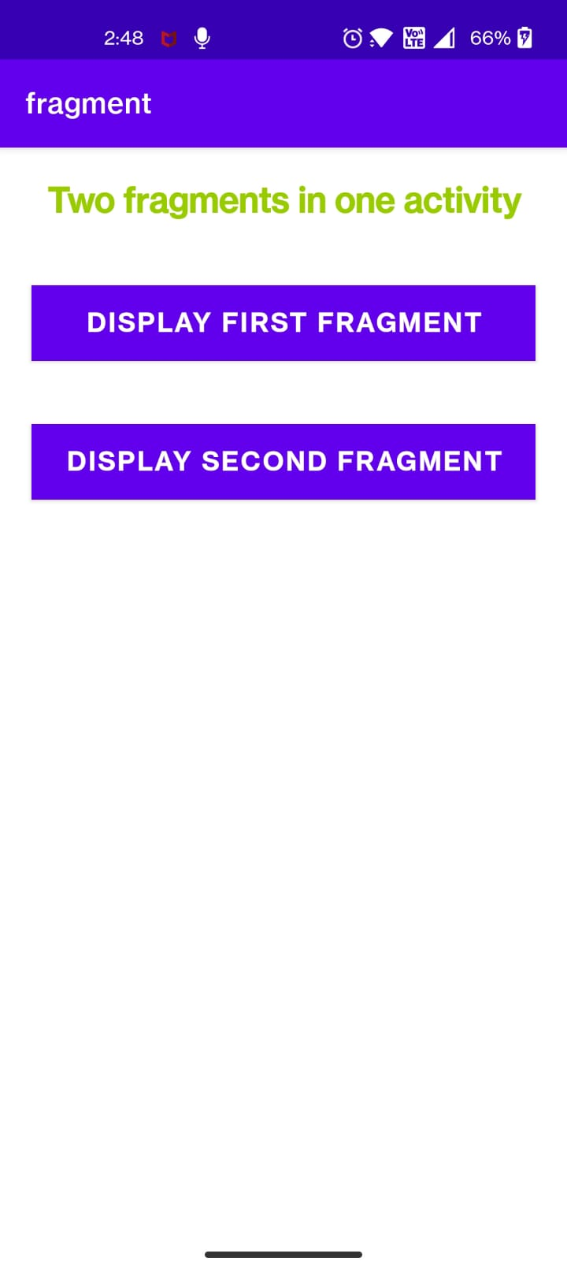

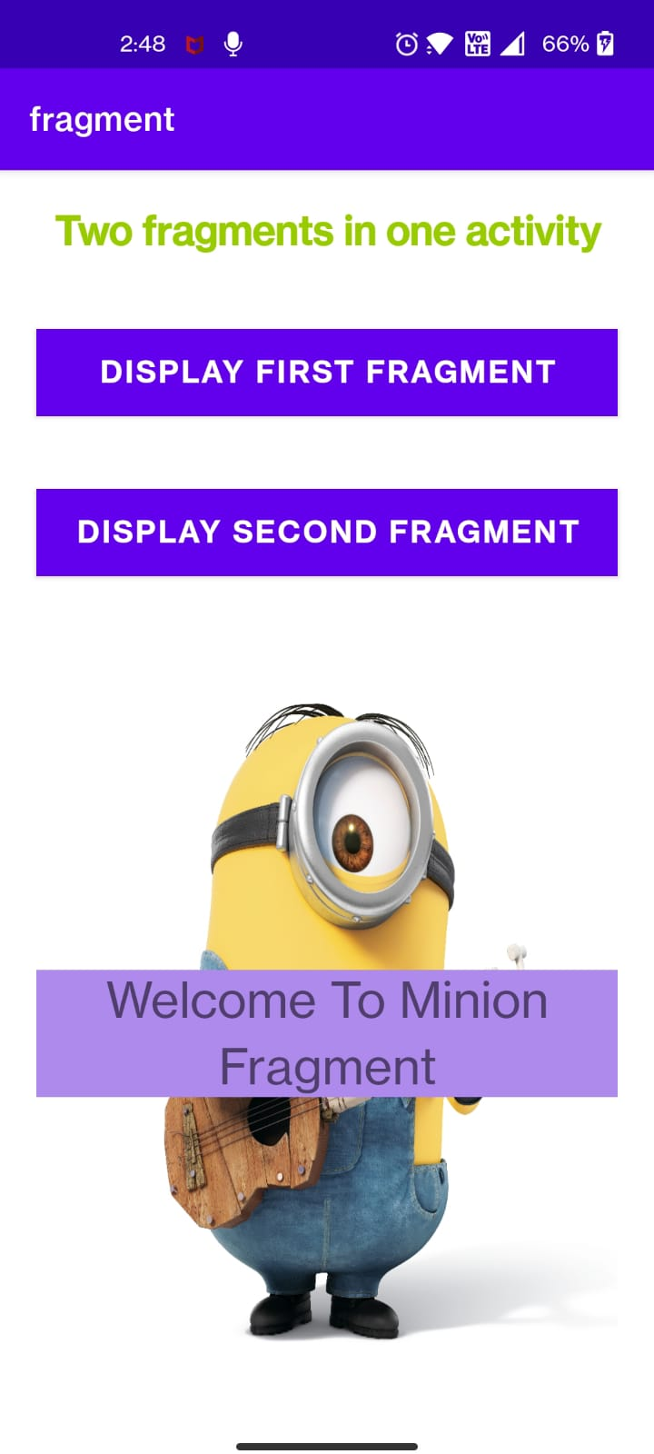

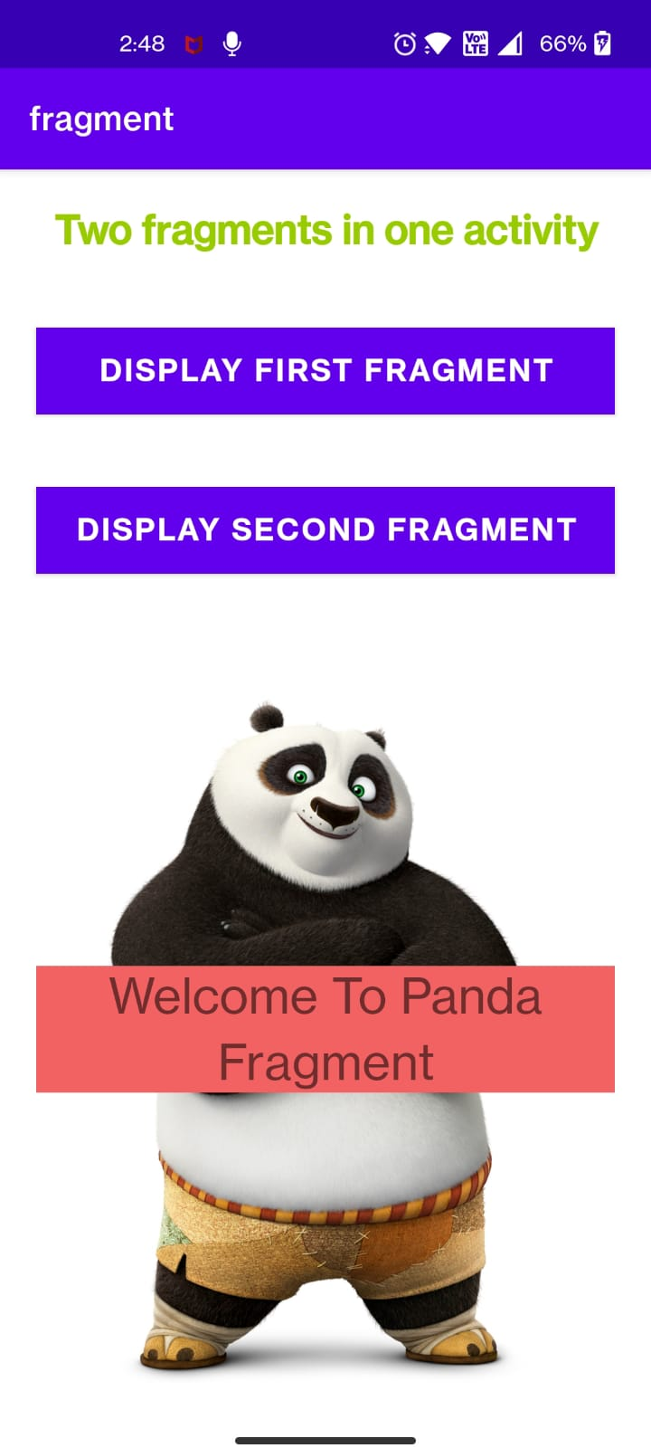

1. Demonstrate Array Adapter using List View to display list of fruits.

Ans:

Java:

**package** com.example.listview;  
  
**import** androidx.appcompat.app.AppCompatActivity;  
**import** android.os.Bundle;  
**import** android.view.View;  
**import** android.widget.AdapterView;  
**import** android.widget.ListView;  
**import** android.widget.Toast;  
**public class** MainActivity **extends** AppCompatActivity {  
 ListView **list**;  
 String **technology**[] = {**"ReactJs"**, **"ExpressJs"**, **"Android"**, **"NodeJs"**, **"Python"**};  
  
 Integer[] **imgid** = {  
 R.drawable.***react***,  
 R.drawable.***express***,  
 R.drawable.***android***,  
 R.drawable.***node***,  
 R.drawable.***python*** };  
  
 @Override  
 **protected void** onCreate(Bundle savedInstanceState) {  
 **super**.onCreate(savedInstanceState);  
 setContentView(R.layout.***activity_main***);  
 **list** = findViewById(R.id.***list***);  
 MylistAdapter adapter = **new** MylistAdapter(**this**, **technology**, **imgid**);  
 **list**.setAdapter(adapter);  
 **list**.setOnItemClickListener(**new** AdapterView.OnItemClickListener() {  
 @Override  
 **public void** onItemClick(AdapterView<?> adapterView, View view, **int** i, **long** l) {  
 Toast.*makeText*(getApplicationContext(), **"Selceted Technology is : "** + **technology**[i], Toast.***LENGTH_LONG***).show();  
 }  
 });  
 }  
}

Xml:

*<?***xml version="1.0" encoding="utf-8"***?>*<**RelativeLayout xmlns:android="http://schemas.android.com/apk/res/android"  
 xmlns:app="http://schemas.android.com/apk/res-auto"  
 xmlns:tools="http://schemas.android.com/tools"  
 android:layout_width="match_parent"  
 android:layout_height="match_parent"  
 tools:context=".MainActivity"** >  
<**ListView  
android:id="@+id/list"  
android:layout_width="match_parent"  
android:layout_height="wrap_content"  
android:layout_marginBottom="50dp"** />  
 </**RelativeLayout**>

myList:

*<?***xml version="1.0" encoding="utf-8"***?>*<**LinearLayout xmlns:android="http://schemas.android.com/apk/res/android"  
 android:layout_width="match_parent"  
 android:layout_height="match_parent"**>  
  
 <**ImageView  
 android:id="@+id/icon"  
 android:layout_width="60dp"  
 android:layout_height="60dp"  
 android:padding="5dp"** />  
  
 <**LinearLayout  
 android:layout_width="wrap_content"  
 android:layout_height="wrap_content"  
 android:orientation="vertical"**>  
  
 <**TextView  
 android:id="@+id/title"  
 android:layout_width="wrap_content"  
 android:layout_height="wrap_content"  
 android:layout_marginLeft="10dp"  
 android:layout_marginTop="5dp"  
 android:padding="2dp"  
 android:text="Medium Text"  
 android:textAppearance="?android:attr/textAppearanceMedium"  
 android:textColor="#4d4d4d"  
 android:textStyle="bold"** />  
 </**LinearLayout**>  
</**LinearLayout**>

DataXml:

*<?***xml version="1.0" encoding="utf-8"***?>*<**resources**>  
 <**string-array name="technology"**>  
 <**item**>ReactJs</**item**>  
 <**item**>ExpressJs</**item**>  
 <**item**>Android</**item**>  
 <**item**>NodeJs</**item**>  
 <**item**>Python</**item**>  
  
</**string-array**>  
</**resources**>

Output:

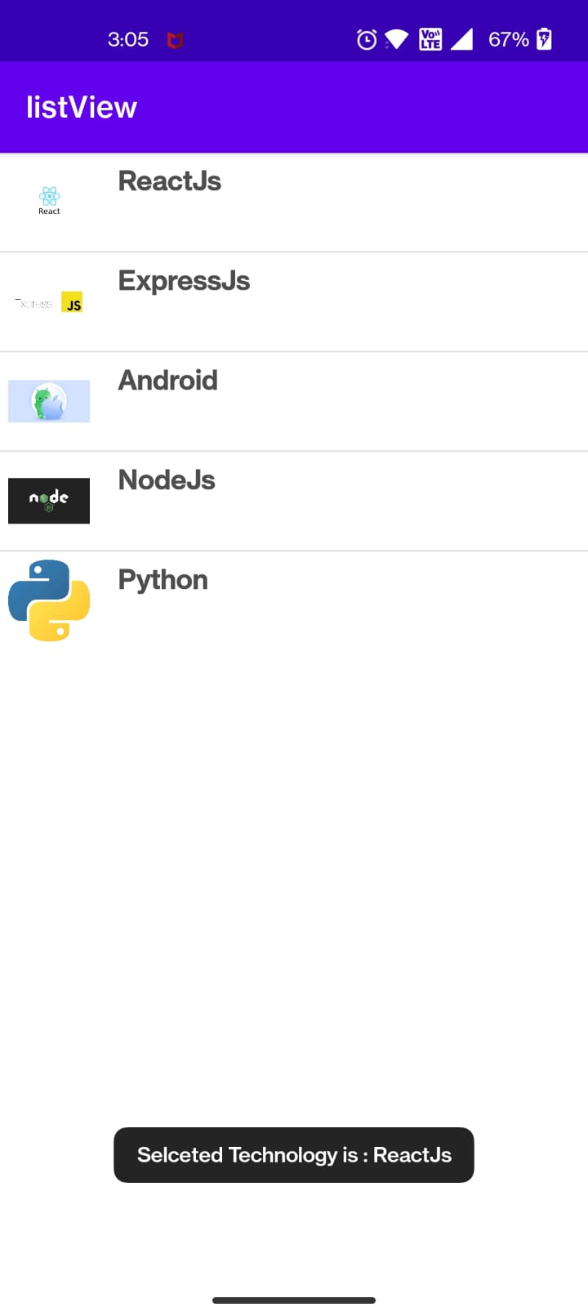

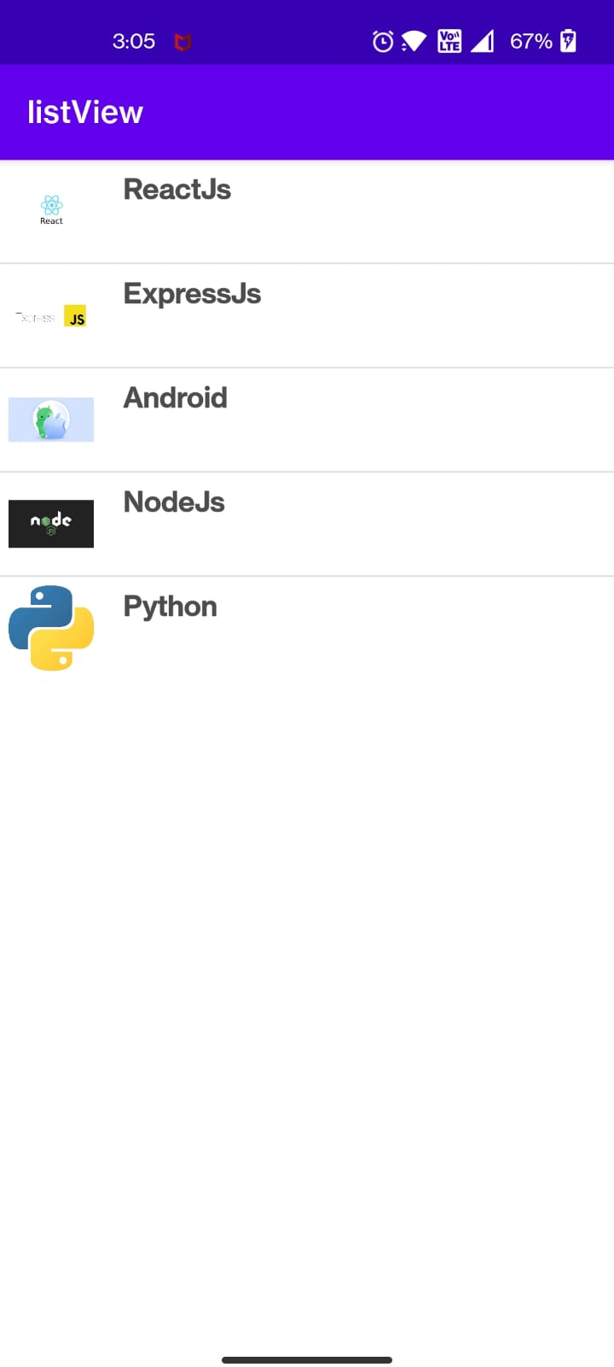

1. Write an application to demonstrate Alert Dialog Box in android.

Ans:

Java:

**package** com.example.alertdialog;  
  
**import** androidx.appcompat.app.AlertDialog;  
**import** androidx.appcompat.app.AppCompatActivity;  
  
**import** android.content.DialogInterface;  
**import** android.os.Bundle;  
**import** android.view.View;  
**import** android.widget.Button;  
**import** android.widget.TextView;  
  
**public class** MainActivity **extends** AppCompatActivity {  
 Button **mbtn**;  
 TextView **txtv**;  
 AlertDialog.Builder **alert** = **null**;  
  
 @Override  
 **protected void** onCreate(Bundle savedInstanceState) {  
 **super**.onCreate(savedInstanceState);  
 setContentView(R.layout.***activity_main***);  
  
 **mbtn** = findViewById(R.id.***btn1***);  
 **txtv** = findViewById(R.id.***textView2***);  
**mbtn**.setOnClickListener(**new** View.OnClickListener() {  
 @Override  
 **public void** onClick(View view) {  
 **alert** = **new** AlertDialog.Builder(MainActivity.**this**);  
  
 **alert**.setMessage(**"This is an Alert Box!!"**);  
 **alert**.setTitle(**"Alert Message"**);  
  
 **alert**.setPositiveButton(**"OK"**, **new** DialogInterface.OnClickListener() {  
 @Override  
 **public void** onClick(DialogInterface dialogInterface, **int** which) {  
 **txtv**.setText(R.string.***strok***);  
 }  
 });  
 **alert**.setNegativeButton(**"Cancel"**, **new** DialogInterface.OnClickListener() {  
 @Override  
 **public void** onClick(DialogInterface dialogInterface, **int** which) {  
 **txtv**.setText(R.string.***strcancel***);  
 }  
 });  
 **alert**.setNeutralButton(**"Remind Me Later"**, **new** DialogInterface.OnClickListener() {  
 @Override  
 **public void** onClick(DialogInterface dialogInterface, **int** which) {  
 **txtv**.setText(R.string.***remind***);  
 }  
 });  
 **alert**.show();  
 }  
});  
  
  
 }  
}

Xml:

*<?***xml version="1.0" encoding="utf-8"***?>*<**androidx.constraintlayout.widget.ConstraintLayout xmlns:android="http://schemas.android.com/apk/res/android"  
 xmlns:app="http://schemas.android.com/apk/res-auto"  
 xmlns:tools="http://schemas.android.com/tools"  
 android:layout_width="match_parent"  
 android:layout_height="match_parent"  
 tools:context=".MainActivity"**>  
  
 <**TextView  
 android:id="@+id/textView2"  
 android:layout_width="210dp"  
 android:layout_height="38dp"  
 android:gravity="center"  
 android:text="CLICK BELOW"  
 android:textSize="16sp"  
 android:textStyle="bold"  
 app:layout_constraintBottom_toBottomOf="parent"  
 app:layout_constraintLeft_toLeftOf="parent"  
 app:layout_constraintRight_toRightOf="parent"  
 app:layout_constraintTop_toTopOf="parent"** />  
  
 <**Button  
 android:id="@+id/btn1"  
 android:layout_width="wrap_content"  
 android:layout_height="wrap_content"  
 android:text="Click"  
 app:layout_constraintBottom_toBottomOf="parent"  
 app:layout_constraintEnd_toEndOf="parent"  
 app:layout_constraintStart_toStartOf="parent"  
 app:layout_constraintTop_toBottomOf="@+id/textView2"  
 app:layout_constraintVertical_bias="0.155"** />  
</**androidx.constraintlayout.widget.ConstraintLayout**>

Output:

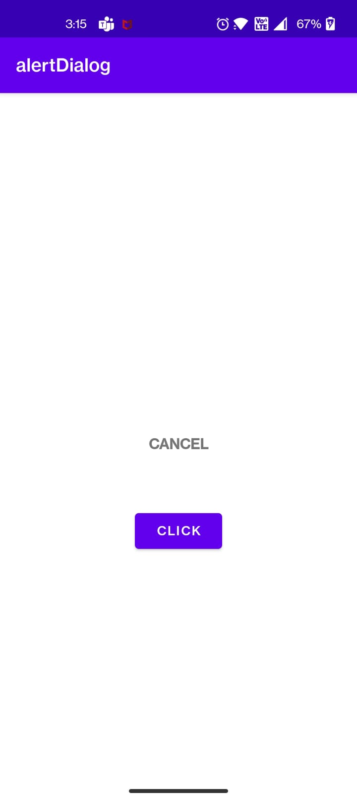

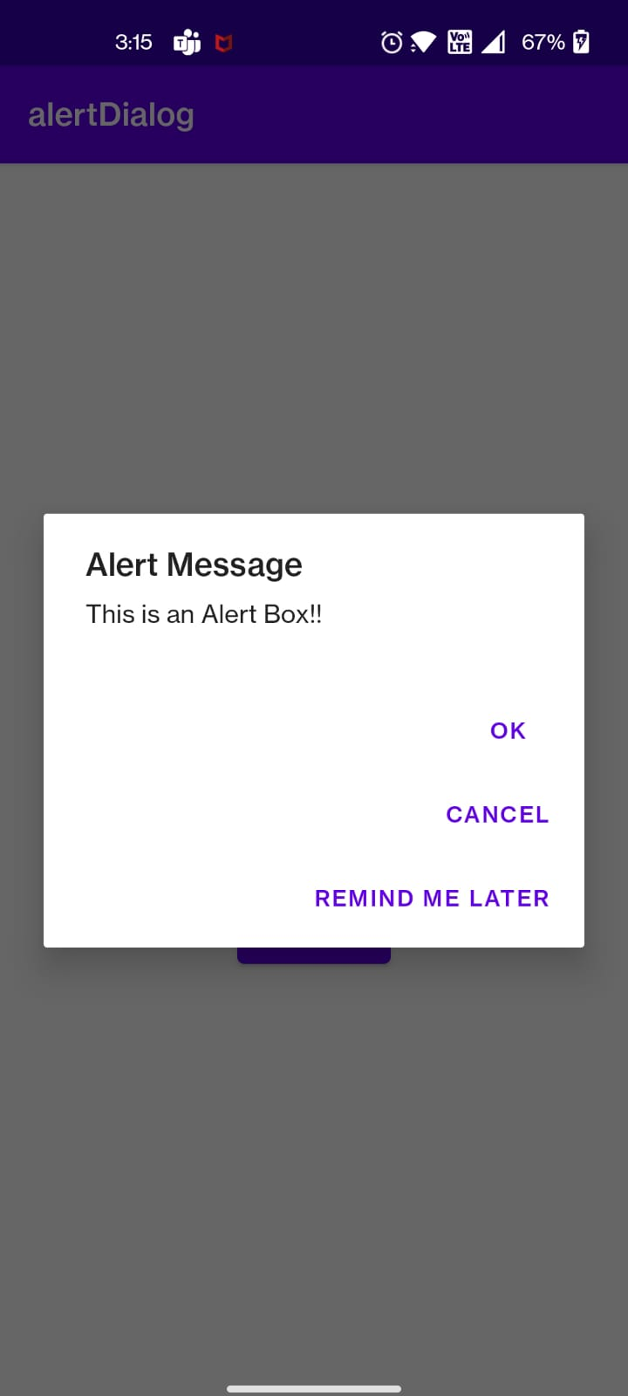

1. Write a program to demonstrate Options Menu in android for a restaurant and display appropriate message related to the dish user has opted from the menu on text field.

Ans:

Java:

**package** com.example.optionmenu;  
  
**import** android.annotation.SuppressLint;  
**import** android.os.Bundle;  
**import** android.view.Menu;  
**import** android.view.MenuItem;  
**import** android.widget.TextView;  
  
**import** androidx.appcompat.app.AppCompatActivity;  
  
**public class** OptionMenu **extends** AppCompatActivity {  
  
 **private** TextView **greetingView**;  
  
 **protected void** onCreate(Bundle savedInstanceState) {  
 **super**.onCreate(savedInstanceState);  
 setContentView(R.layout.***optionmenu***);  
 **greetingView** = (TextView) findViewById(R.id.***newMessage***);  
 }  
  
 @SuppressLint(**"ResourceType"**)  
 @Override  
 **public boolean** onCreateOptionsMenu(Menu menu) {  
 *// Inflate the menu; this adds items to the action bar if it is present.* getMenuInflater().inflate(R.menu.***menu_main***, menu);  
 **return true**;  
 }  
  
 @Override  
 **public boolean** onOptionsItemSelected(MenuItem item) {  
 **int** id = item.getItemId();  
 **switch** (id){  
 **case** R.id.***item1***:  
 **greetingView**.setText(**"Customer Opted Muesli"**);  
 **return true**;  
 **case** R.id.***item2***:  
 **greetingView**.setText(**"Customer Opted Oats"**);  
 **return true**;  
 **case** R.id.***item3***:  
 **greetingView**.setText(**"Customer Opted Shahi Paneer"**);  
 **return true**;  
 **case** R.id.***item4***:  
 **greetingView**.setText(**"Customer Opted Pani Puri"**);  
 **default**:  
 **return super**.onOptionsItemSelected(item);  
 }  
 }  
}

Xml:

<**menu  
 xmlns:android="http://schemas.android.com/apk/res/android"  
 xmlns:app="http://schemas.android.com/apk/res-auto"  
 xmlns:tools="http://schemas.android.com/tools"  
 tools:context=".OptionMenu"**>  
  
 <**item  
 android:id="@+id/item1"  
 android:title="Muesli"** />  
 <**item  
 android:id="@+id/item2"  
 android:title="Oats"** />  
 <**item  
 android:id="@+id/item3"  
 android:title="Shahi Paneer"  
 app:showAsAction="withText"** />  
 <**item  
 android:id="@+id/item4"  
 android:title="Pani Puri"** />  
</**menu**>

optionXml:

*<?***xml version="1.0" encoding="utf-8"***?>*<**androidx.coordinatorlayout.widget.CoordinatorLayout  
 xmlns:android="http://schemas.android.com/apk/res/android"  
 xmlns:tools="http://schemas.android.com/tools"  
 android:layout_width="match_parent"  
 android:layout_height="match_parent"  
 tools:context=".OptionMenu"**>  
  
 <**com.google.android.material.appbar.AppBarLayout  
 android:id="@+id/app"  
 android:layout_width="match_parent"  
 android:layout_height="wrap_content"**>  
  
 <**android.widget.Toolbar  
 android:id="@+id/toolbar"  
 android:layout_width="match_parent"  
 android:layout_height="0dp"  
 android:background="?attr/colorPrimary"**/>  
  
 </**com.google.android.material.appbar.AppBarLayout**>  
  
 <**include layout="@layout/content_main"** />  
  
</**androidx.coordinatorlayout.widget.CoordinatorLayout**>

contentXml:

*<?***xml version="1.0" encoding="utf-8"***?>*<**androidx.constraintlayout.widget.ConstraintLayout  
 xmlns:android="http://schemas.android.com/apk/res/android"  
 xmlns:app="http://schemas.android.com/apk/res-auto"  
 xmlns:tools="http://schemas.android.com/tools"  
 android:layout_width="match_parent"  
 android:layout_height="match_parent"  
 android:layout_marginLeft="20dp"  
 android:layout_marginRight="20dp"  
 tools:context=".OptionMenu"  
 tools:showIn="@layout/optionmenu"**>  
  
 <**TextView  
 android:id="@+id/newMessage"  
 android:layout_width="333dp"  
 android:layout_height="72dp"  
 android:gravity="center"  
 android:textSize="16sp"  
 android:textStyle="bold"  
 app:layout_constraintBottom_toBottomOf="parent"  
 app:layout_constraintHorizontal_bias="0.578"  
 app:layout_constraintLeft_toLeftOf="parent"  
 app:layout_constraintRight_toRightOf="parent"  
 app:layout_constraintTop_toTopOf="parent"  
 app:layout_constraintVertical_bias="0.825"** />  
  
</**androidx.constraintlayout.widget.ConstraintLayout**>

Output:

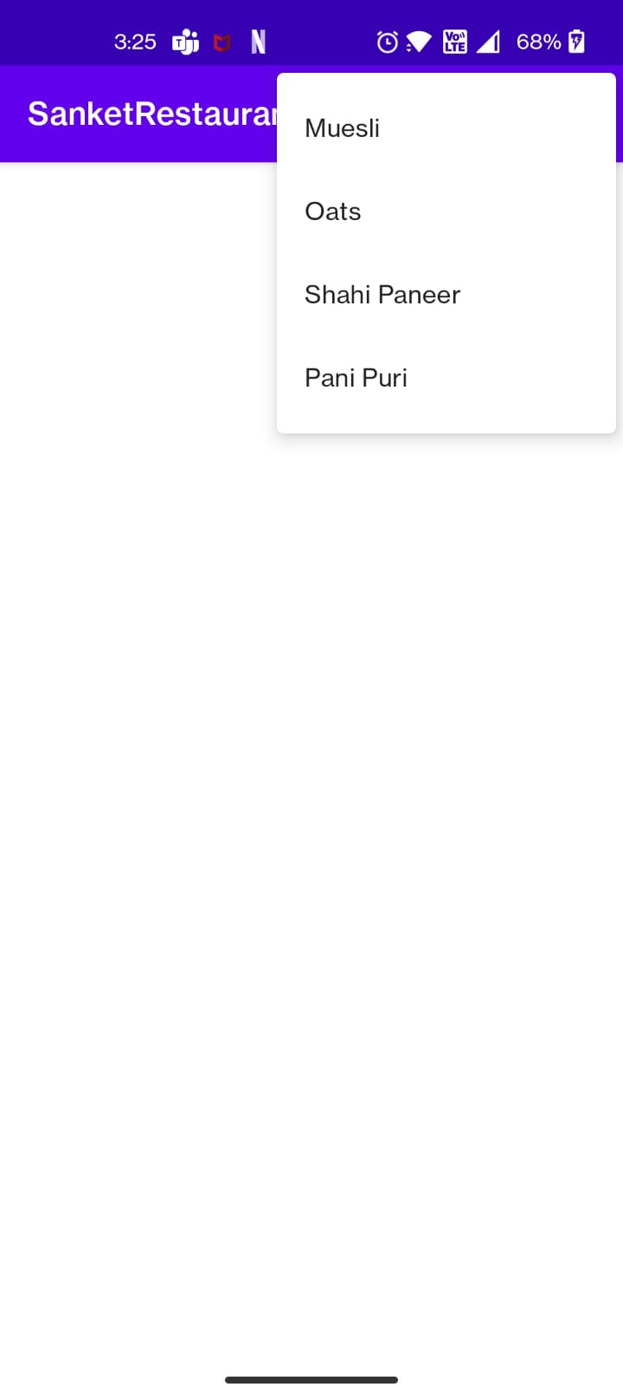

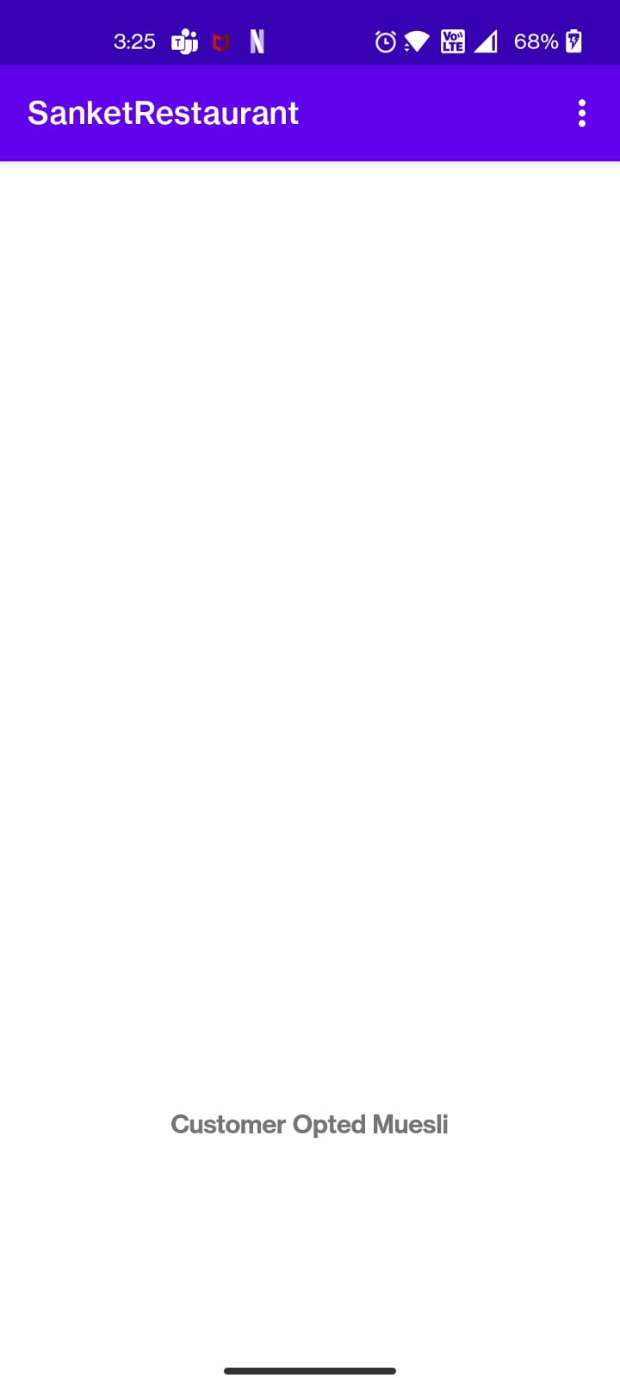

1. Write a program to demonstrate Context Menu in android for notepad

Ans:

Java:

**package** com.example.contextmenu;  
  
**import** androidx.annotation.NonNull;  
**import** androidx.appcompat.app.AppCompatActivity;  
  
**import** android.content.res.Resources;  
**import** android.os.Bundle;  
**import** android.view.ContextMenu;  
**import** android.view.Menu;  
**import** android.view.MenuInflater;  
**import** android.view.MenuItem;  
**import** android.view.View;  
**import** android.widget.Switch;  
**import** android.widget.TextView;  
**import** android.widget.Toast;  
  
**public class** MainActivity **extends** AppCompatActivity {  
TextView **txt1**,**txt2**,**txt3**,**txt4**,**txt5**;  
 @Override  
 **protected void** onCreate(Bundle savedInstanceState) {  
 **super**.onCreate(savedInstanceState);  
 setContentView(R.layout.***activity_main***);  
 **txt1**=findViewById(R.id.***file***);  
 **txt2**=findViewById(R.id.***edit***);  
 **txt3**=findViewById(R.id.***format***);  
 **txt4**=findViewById(R.id.***view***);  
 **txt5**=findViewById(R.id.***help***);  
 registerForContextMenu(**txt1**);  
 registerForContextMenu(**txt2**);  
 registerForContextMenu(**txt3**);  
 registerForContextMenu(**txt4**);  
 registerForContextMenu(**txt5**);  
 }  
  
 @Override  
 **public void** onCreateContextMenu(ContextMenu menu, View v, ContextMenu.ContextMenuInfo menuInfo) {  
 **super**.onCreateContextMenu(menu, v, menuInfo);  
 **int** id=v.getId();  
 **if**(id==R.id.***file***)  
 {  
 MenuInflater mi=getMenuInflater();  
 mi.inflate(R.menu.***file***,menu);  
 }  
  
 **if**(id==R.id.***edit***)  
 {  
 MenuInflater mi=getMenuInflater();  
 mi.inflate(R.menu.***edit***,menu);  
 }  
 **if**(id==R.id.***format***)  
 {  
 MenuInflater mi=getMenuInflater();  
 mi.inflate(R.menu.***format***,menu);  
 }  
 **if**(id==R.id.***view***)  
 {  
 MenuInflater mi=getMenuInflater();  
 mi.inflate(R.menu.***view***,menu);  
 }  
 **if**(id==R.id.***help***)  
 {  
 MenuInflater mi=getMenuInflater();  
 mi.inflate(R.menu.***help***,menu);  
 }  
  
 }  
  
 @Override  
 **public boolean** onContextItemSelected(@NonNull MenuItem item) {  
 **super**.onContextItemSelected(item);  
 **int** id=item.getItemId();  
 Resources r=getResources();  
 **switch**(id)  
 {  
 **case** R.id.***file1***:  
 Toast.*makeText*(**this**, **"New"**, Toast.***LENGTH_SHORT***).show();  
 **break**;  
 **case** R.id.***file2***:  
 Toast.*makeText*(**this**, **"New Window"**, Toast.***LENGTH_SHORT***).show();  
 **break**;  
 **case** R.id.***file3***:  
 Toast.*makeText*(**this**, **"Open"**, Toast.***LENGTH_SHORT***).show();  
 **break**;  
 **case** R.id.***file4***:  
 Toast.*makeText*(**this**, **"Save"**, Toast.***LENGTH_SHORT***).show();  
 **break**;  
 **case** R.id.***file5***:  
 Toast.*makeText*(**this**, **"Save As"**, Toast.***LENGTH_SHORT***).show();  
 **break**;  
 **case** R.id.***edit1***:  
 Toast.*makeText*(**this**, **"Undo"**, Toast.***LENGTH_SHORT***).show();  
 **break**;  
 **case** R.id.***edit2***:  
 Toast.*makeText*(**this**, **"Cut"**, Toast.***LENGTH_SHORT***).show();  
 **break**;  
 **case** R.id.***edit3***:  
 Toast.*makeText*(**this**, **"Copy"**, Toast.***LENGTH_SHORT***).show();  
 **break**;  
 **case** R.id.***edit4***:  
 Toast.*makeText*(**this**, **"Paste"**, Toast.***LENGTH_SHORT***).show();  
 **break**;  
 **case** R.id.***edit5***:  
 Toast.*makeText*(**this**, **"Delete"**, Toast.***LENGTH_SHORT***).show();  
 **break**;  
 **case** R.id.***format1***:  
 Toast.*makeText*(**this**, **"Word Wrap"**, Toast.***LENGTH_SHORT***).show();  
 **break**;  
 **case** R.id.***format2***:  
 Toast.*makeText*(**this**, **"Font"**, Toast.***LENGTH_SHORT***).show();  
 **break**;  
 **case** R.id.***view1***:  
 Toast.*makeText*(**this**, **"Zoom"**, Toast.***LENGTH_SHORT***).show();  
 **break**;  
 **case** R.id.***view2***:  
 Toast.*makeText*(**this**, **"Status Bar"**, Toast.***LENGTH_SHORT***).show();  
 **break**;  
 **case** R.id.***help1***:  
 Toast.*makeText*(**this**, **"View Help"**, Toast.***LENGTH_SHORT***).show();  
 **break**;  
 **case** R.id.***help2***:  
 Toast.*makeText*(**this**, **"Send Feedback"**, Toast.***LENGTH_SHORT***).show();  
 **break**;  
 **case** R.id.***help3***:  
 Toast.*makeText*(**this**, **"About Notepad"**, Toast.***LENGTH_SHORT***).show();  
 **break**;  
 }  
 **return true**;  
 }  
}

Xml:

*<?***xml version="1.0" encoding="utf-8"***?>*<**androidx.constraintlayout.widget.ConstraintLayout xmlns:android="http://schemas.android.com/apk/res/android"  
 xmlns:app="http://schemas.android.com/apk/res-auto"  
 xmlns:tools="http://schemas.android.com/tools"  
 android:layout_width="match_parent"  
 android:layout_height="match_parent"  
 android:background="#FFF3E1"  
 tools:context=".MainActivity"**>  
  
 <**TextView  
 android:id="@+id/file"  
 android:layout_width="70dp"  
 android:layout_height="24dp"  
 android:background="#30736D"  
 android:gravity="center"  
 android:text="File"  
 android:textColor="#FCFBFB"  
 android:textSize="16sp"  
 android:textStyle="bold"  
 app:layout_constraintBottom_toBottomOf="parent"  
 app:layout_constraintEnd_toEndOf="parent"  
 app:layout_constraintHorizontal_bias="0.0"  
 app:layout_constraintStart_toStartOf="parent"  
 app:layout_constraintTop_toTopOf="parent"  
 app:layout_constraintVertical_bias="0.0"** />  
  
 <**TextView  
 android:id="@+id/edit"  
 android:layout_width="70dp"  
 android:layout_height="24dp"  
 android:background="#E4A23F"  
 android:gravity="center"  
 android:text="Edit"  
 android:textColor="#FEFEFE"  
 android:textSize="16sp"  
 android:textStyle="bold"  
 app:layout_constraintBottom_toBottomOf="parent"  
 app:layout_constraintEnd_toEndOf="parent"  
 app:layout_constraintHorizontal_bias="0.205"  
 app:layout_constraintStart_toStartOf="parent"  
 app:layout_constraintTop_toTopOf="parent"  
 app:layout_constraintVertical_bias="0.0"** />  
  
 <**TextView  
 android:id="@+id/format"  
 android:layout_width="70dp"  
 android:layout_height="24dp"  
 android:background="#8ACCE8"  
 android:gravity="center"  
 android:text="Format"  
 android:textColor="#FEFDFD"  
 android:textSize="16sp"  
 android:textStyle="bold"  
 app:layout_constraintBottom_toBottomOf="parent"  
 app:layout_constraintEnd_toEndOf="parent"  
 app:layout_constraintHorizontal_bias="0.41"  
 app:layout_constraintStart_toStartOf="parent"  
 app:layout_constraintTop_toTopOf="parent"  
 app:layout_constraintVertical_bias="0.0"** />  
  
 <**TextView  
 android:id="@+id/help"  
 android:layout_width="70dp"  
 android:layout_height="24dp"  
 android:background="#5FEC6C"  
 android:gravity="center"  
 android:text="Help"  
 android:textColor="#FCFBFB"  
 android:textSize="16sp"  
 android:textStyle="bold"  
 app:layout_constraintBottom_toBottomOf="parent"  
 app:layout_constraintEnd_toEndOf="parent"  
 app:layout_constraintHorizontal_bias="0.821"  
 app:layout_constraintStart_toStartOf="parent"  
 app:layout_constraintTop_toTopOf="parent"  
 app:layout_constraintVertical_bias="0.0"** />  
  
 <**TextView  
 android:id="@+id/view"  
 android:layout_width="70dp"  
 android:layout_height="24dp"  
 android:background="#EF8F87"  
 android:gravity="center"  
 android:text="View"  
 android:textColor="#FCFBFB"  
 android:textSize="16sp"  
 android:textStyle="bold"  
 app:layout_constraintBottom_toBottomOf="parent"  
 app:layout_constraintEnd_toEndOf="parent"  
 app:layout_constraintHorizontal_bias="0.615"  
 app:layout_constraintStart_toStartOf="@+id/file"  
 app:layout_constraintTop_toTopOf="parent"  
 app:layout_constraintVertical_bias="0.0"** />  
  
</**androidx.constraintlayout.widget.ConstraintLayout**>

Output:

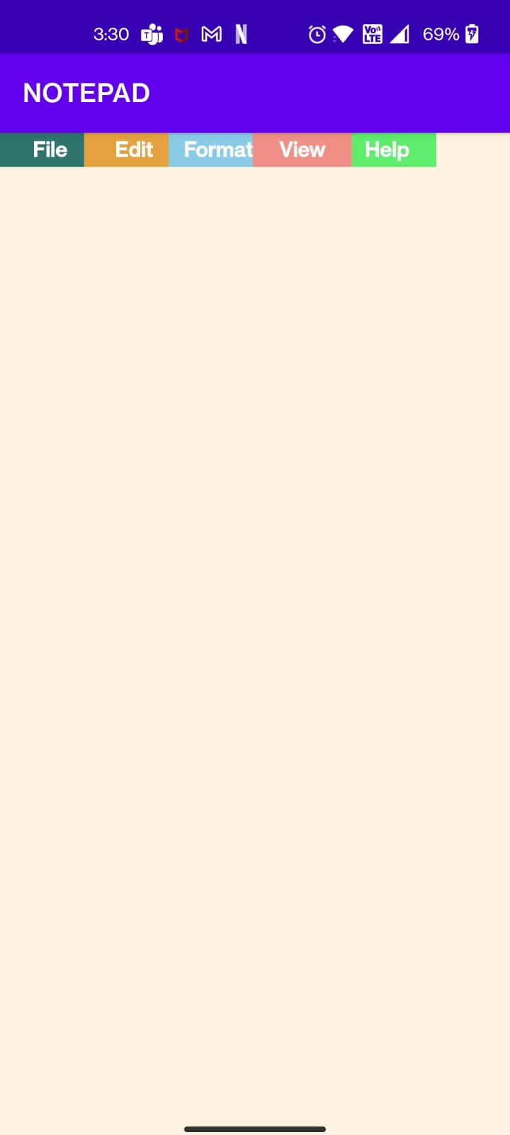

1. Write a program to demonstrate Popup Menu in android for cut, copy and paste options in it and display appropriate information related to operation.

Ans:

Java:

**package** com.example.popup;  
  
**import** androidx.appcompat.app.AppCompatActivity;  
  
**import** android.os.Bundle;  
**import** android.view.MenuItem;  
**import** android.view.View;  
**import** android.widget.Button;  
**import** android.widget.PopupMenu;  
**import** android.widget.Toast;  
  
**public class** MainActivity **extends** AppCompatActivity {  
 Button **button**;  
 @Override  
 **protected void** onCreate(Bundle savedInstanceState) {  
 **super**.onCreate(savedInstanceState);  
 setContentView(R.layout.***activity_main***);  
  
 **button**=findViewById(R.id.***button***);  
 **button**.setOnClickListener(**new** View.OnClickListener() {  
 @Override  
 **public void** onClick(View view) {  
 *//creating instance of popupMenu* PopupMenu popup=**new** PopupMenu(MainActivity.**this**,**button**);  
  
 *//inflating the popup using xml* popup.getMenuInflater().inflate(R.menu.***menu_main***,popup.getMenu());  
  
 *//registering popup with OnMenuItem* popup.setOnMenuItemClickListener(**new** PopupMenu.OnMenuItemClickListener() {  
 @Override  
 **public boolean** onMenuItemClick(MenuItem menuItem) {  
 String s1,s2,s3;  
 s1=**"The Cut command is used to remove text or images from the screen you are currently working on. \"CUT\" moves the information to your virtual clipboard, where it is stored until it is overwritten by the next \"cut\" or \"copy\" command."**;  
 s2=**"copy means trying to duplicate a thing as much as possible. Copy this drawing exactly. imitate means that a person uses something as an example but does not try to make an exact copy."**;  
 s3=**"A paste operation takes place which visibly inserts the clipboard text at the insertion point."**;  
 **int** i=menuItem.getItemId();  
 **switch** (i)  
 {  
 **case** R.id.***one***:  
 Toast.*makeText*(MainActivity.**this**, s1, Toast.***LENGTH_SHORT***).show();  
 **break**;  
 **case** R.id.***two***:  
 Toast.*makeText*(MainActivity.**this**, s2, Toast.***LENGTH_SHORT***).show();  
 **break**;  
 **case** R.id.***three***:  
 Toast.*makeText*(MainActivity.**this**, s3, Toast.***LENGTH_SHORT***).show();  
 **break**;  
 }  
  
 **return true**;  
 }  
 });  
 popup.show();  
  
 }  
 });  
 }  
}

Xml:

*<?***xml version="1.0" encoding="utf-8"***?>*<**androidx.constraintlayout.widget.ConstraintLayout xmlns:android="http://schemas.android.com/apk/res/android"  
 xmlns:app="http://schemas.android.com/apk/res-auto"  
 xmlns:tools="http://schemas.android.com/tools"  
 android:layout_width="match_parent"  
 android:layout_height="match_parent"  
 tools:context=".MainActivity"**>  
  
 <**Button  
 android:id="@+id/button"  
 android:layout_width="wrap_content"  
 android:layout_height="wrap_content"  
 android:layout_marginTop="8dp"  
 android:text="Click"  
 app:layout_constraintBottom_toBottomOf="parent"  
 app:layout_constraintEnd_toEndOf="parent"  
 app:layout_constraintHorizontal_bias="0.5"  
 app:layout_constraintStart_toStartOf="parent"  
 app:layout_constraintTop_toTopOf="parent"**/>  
  
</**androidx.constraintlayout.widget.ConstraintLayout**>

Output:

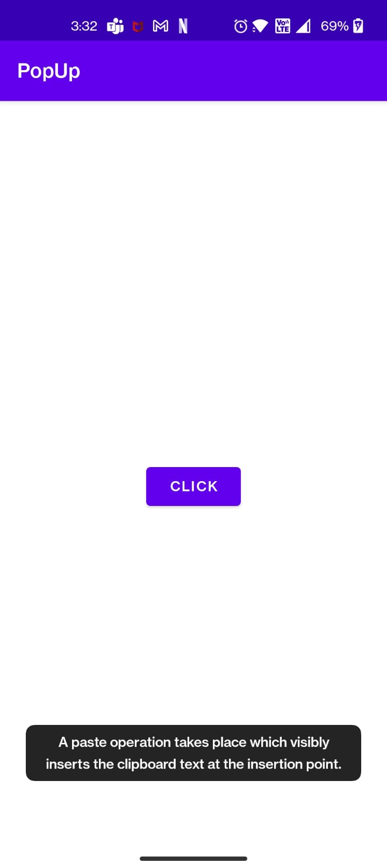

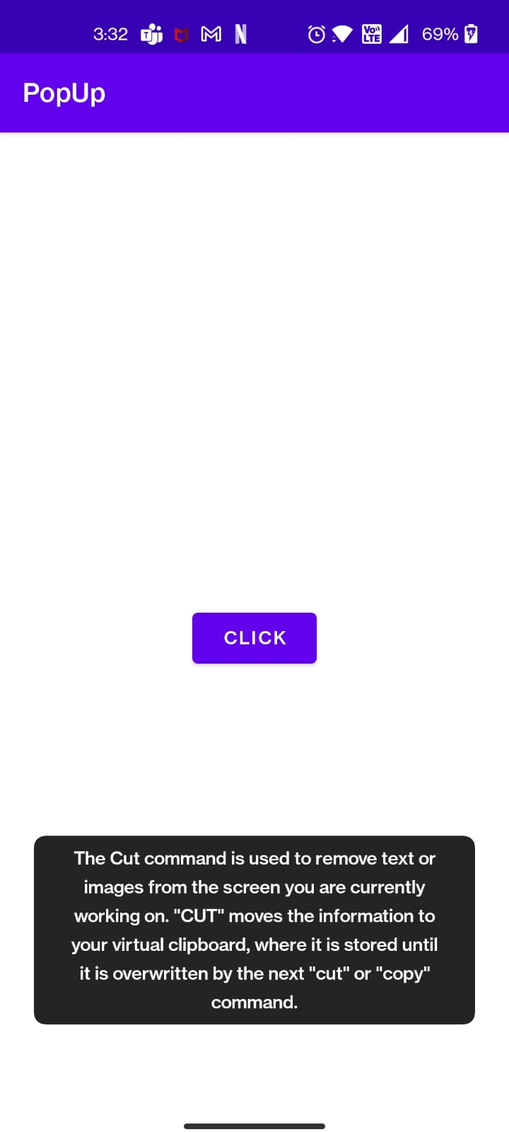

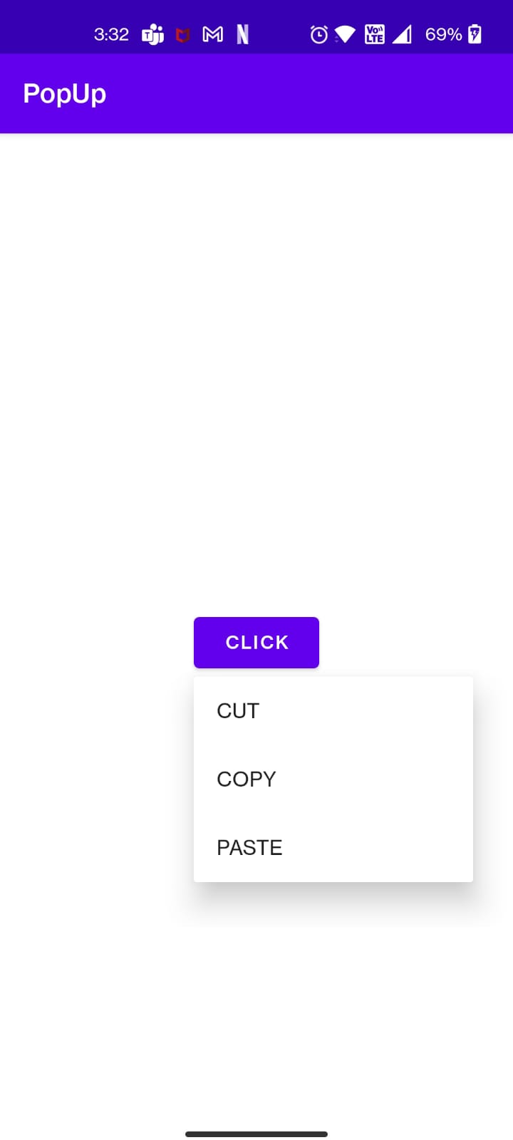

1. Write an application to produce Notification.

Ans:

Java:

**package** com.example.notification;  
  
**import** androidx.appcompat.app.AppCompatActivity;  
**import** androidx.core.app.NotificationCompat;  
**import** androidx.core.app.NotificationManagerCompat;  
  
**import** android.app.NotificationChannel;  
**import** android.app.NotificationManager;  
**import** android.net.Uri;  
**import** android.os.Build;  
**import** android.os.Bundle;  
**import** android.view.View;  
**import** android.widget.Button;  
  
**public class** MainActivity **extends** AppCompatActivity {  
 Button **b**;  
 @Override  
 **protected void** onCreate(Bundle savedInstanceState) {  
 **super**.onCreate(savedInstanceState);  
 setContentView(R.layout.***activity_main***);  
 **b**=findViewById(R.id.***btn***);  
 **b**.setOnClickListener(**new** View.OnClickListener() {  
 @Override  
 **public void** onClick(View view) {  
 notification();  
 }  
 });  
 }  
 **private void** notification(){  
 **if**(Build.VERSION.***SDK_INT***>=Build.VERSION_CODES.***O***)  
 {  
 NotificationChannel notificationChannel=**new** NotificationChannel(**"n"**,**"n"**, NotificationManager.***IMPORTANCE_DEFAULT***);  
 NotificationManager manager=getSystemService(NotificationManager.**class**);  
 manager.createNotificationChannel(notificationChannel);  
 }  
 NotificationCompat.Builder builder=**new** NotificationCompat.Builder(**this**,**"n"**)  
 .setContentText(**"Hello"**)  
 .setSmallIcon(R.drawable.***notify***)  
 .setAutoCancel(**true**)  
 .setContentText(**"This is notification text"**);  
 NotificationManagerCompat managerCompat=NotificationManagerCompat.*from*(**this**);  
 managerCompat.notify(999,builder.build());  
 }  
}

Xml:

*<?***xml version="1.0" encoding="utf-8"***?>*<**androidx.constraintlayout.widget.ConstraintLayout xmlns:android="http://schemas.android.com/apk/res/android"  
 xmlns:app="http://schemas.android.com/apk/res-auto"  
 xmlns:tools="http://schemas.android.com/tools"  
 android:layout_width="match_parent"  
 android:layout_height="match_parent"  
 tools:context=".MainActivity"**>  
  
 <**Button  
 android:id="@+id/btn"  
 android:layout_width="166dp"  
 android:layout_height="55dp"  
 android:text="Notify"  
 app:layout_constraintBottom_toBottomOf="parent"  
 app:layout_constraintLeft_toLeftOf="parent"  
 app:layout_constraintRight_toRightOf="parent"  
 app:layout_constraintTop_toTopOf="parent"** />  
  
</**androidx.constraintlayout.widget.ConstraintLayout**>

Output:

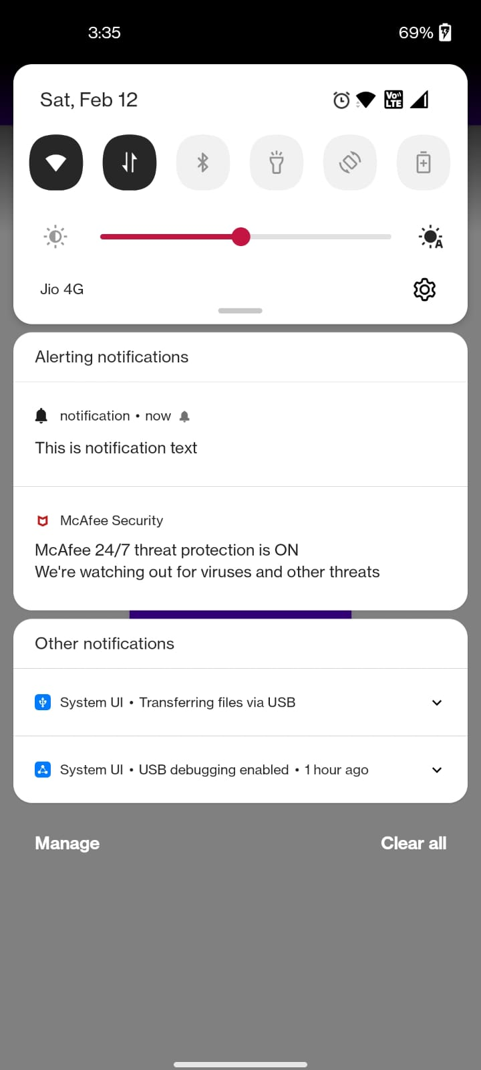

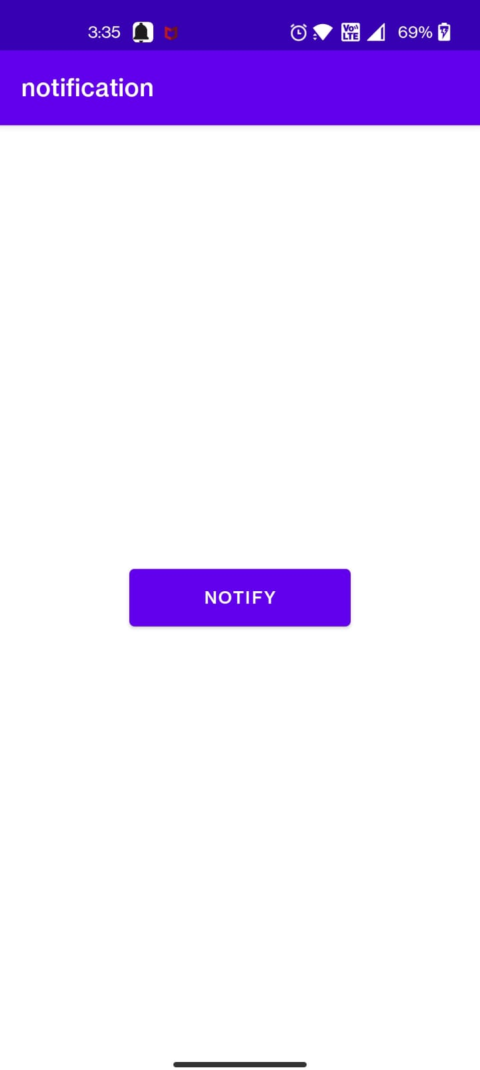

1. Write an android application using shared preference to save score of a game.

Ans:

Java:

**package** com.example.sharedpreference;  
  
**import** androidx.appcompat.app.AppCompatActivity;  
  
**import** android.content.SharedPreferences;  
**import** android.os.Bundle;  
**import** android.view.View;  
**import** android.widget.Button;  
**import** android.widget.EditText;  
**import** android.widget.TextView;  
  
**public class** MainActivity **extends** AppCompatActivity {  
 Button **button**;  
 TextView **textView**,**textView3**;  
 EditText **editText**,**editText1**;  
  
 @Override  
 **protected void** onCreate(Bundle savedInstanceState) {  
 **super**.onCreate(savedInstanceState);  
 setContentView(R.layout.***activity_main***);  
  
 **button** = findViewById(R.id.***button***);  
 **textView3**=findViewById(R.id.***textView3***);  
 **editText1**=findViewById(R.id.***edittext1***);  
  
 **button**.setOnClickListener(**new** View.OnClickListener() {  
 @Override  
 **public void** onClick(View v) {  
 String msg1 = **editText1**.getText().toString();  
 String s=**"The score is "**+msg1;  
 SharedPreferences shrd1 = getSharedPreferences(**"demo1"**, ***MODE_PRIVATE***);  
 SharedPreferences.Editor editor1 = shrd1.edit();  
 editor1.putString(**"demo1"**, s);  
 editor1.apply();  
 **textView3**.setText(s);  
  
  
 }  
 });  
  
 SharedPreferences shrd1 = getSharedPreferences(**"demo1"**, ***MODE_PRIVATE***);  
  
 String value11 = shrd1.getString(**"demo1"**,**""**);  
 **textView3**.setText(value11);  
  
 }  
}

Xml:

*<?***xml version="1.0" encoding="utf-8"***?>*<**androidx.constraintlayout.widget.ConstraintLayout xmlns:android="http://schemas.android.com/apk/res/android"  
 xmlns:app="http://schemas.android.com/apk/res-auto"  
 xmlns:tools="http://schemas.android.com/tools"  
 android:layout_width="match_parent"  
 android:layout_height="match_parent"  
 tools:context=".MainActivity"**>  
  
 <**TextView  
 android:id="@+id/textView4"  
 android:layout_width="301dp"  
 android:layout_height="72dp"  
 android:gravity="center|center_vertical"  
 android:text="Click on submit and game score will show below"  
 android:textSize="20sp"  
 android:textStyle="bold"  
 app:layout_constraintBottom_toBottomOf="parent"  
 app:layout_constraintEnd_toEndOf="parent"  
 app:layout_constraintHorizontal_bias="0.472"  
 app:layout_constraintStart_toStartOf="parent"  
 app:layout_constraintTop_toTopOf="parent"  
 app:layout_constraintVertical_bias="0.684"** />  
  
 <**Button  
 android:id="@+id/button"  
 android:layout_width="wrap_content"  
 android:layout_height="wrap_content"  
 android:layout_marginBottom="320dp"  
  
 android:text="SUBMIT"  
 app:layout_constraintBottom_toBottomOf="parent"  
 app:layout_constraintEnd_toEndOf="parent"  
 app:layout_constraintStart_toStartOf="parent"** />  
  
 <**EditText  
 android:id="@+id/edittext1"  
 android:layout_width="240dp"  
 android:layout_height="47dp"  
 android:ems="10"  
 android:hint="Enter game score"  
 android:inputType="textPersonName"  
 android:textColorHint="#E91E63"  
 app:layout_constraintBottom_toBottomOf="parent"  
 app:layout_constraintEnd_toEndOf="parent"  
 app:layout_constraintHorizontal_bias="0.497"  
 app:layout_constraintStart_toStartOf="parent"  
 app:layout_constraintTop_toTopOf="parent"  
 app:layout_constraintVertical_bias="0.406"** />  
  
 <**TextView  
 android:id="@+id/textView3"  
 android:layout_width="294dp"  
 android:layout_height="45dp"  
 android:layout_marginStart="54dp"  
 android:layout_marginEnd="54dp"  
 android:layout_marginBottom="122dp"  
 android:gravity="center|center_vertical"  
 android:textSize="16sp"  
 android:textStyle="bold"  
 app:layout_constraintBottom_toBottomOf="parent"  
 app:layout_constraintEnd_toEndOf="parent"  
 app:layout_constraintStart_toStartOf="parent"** />  
  
</**androidx.constraintlayout.widget.ConstraintLayout**>

Output:

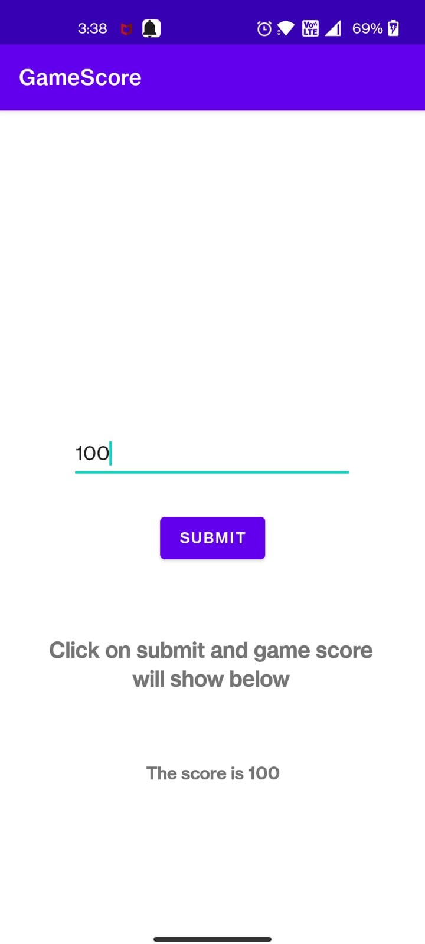

1. Write an android application using SQLite to create table, add employee details and display in logcat.

Ans:

Java:

**package** com.example.sqlitedb;  
  
**import** androidx.appcompat.app.AppCompatActivity;  
  
**import** android.os.Bundle;  
  
**public class** MainActivity **extends** AppCompatActivity {  
  
 @Override  
 **protected void** onCreate(Bundle savedInstanceState) {  
 **super**.onCreate(savedInstanceState);  
 setContentView(R.layout.activity_main);  
 DBHandler dbHandler= **new** DBHandler(**this**,**"empdb"**,**null**,1);  
 dbHandler.addEmployee(**new** Employee(1,**"Sanket"**,121.1));  
 dbHandler.getEmployee(1);  
 dbHandler.close();  
 }  
}

DBHandler:

**package** com.example.sqlitedb;  
  
**import** android.content.ContentValues;  
**import** android.content.Context;  
**import** android.database.Cursor;  
**import** android.database.sqlite.SQLiteDatabase;  
**import** android.database.sqlite.SQLiteOpenHelper;  
**import** android.util.Log;  
  
**import** androidx.annotation.Nullable;  
  
**public class** DBHandler **extends** SQLiteOpenHelper {  
 **private** Log **log**;  
  
 **public** DBHandler(@Nullable Context context, @Nullable String name, @Nullable SQLiteDatabase.CursorFactory factory, **int** version) {  
 **super**(context, name,factory, version);  
 }  
  
 @Override  
 **public void** onCreate(SQLiteDatabase db) {  
 String create =**"CREATE TABLE myemployee(Sno INTEGER PRIMARY KEY, name TEXT, increment TEXT)"**;  
 db.execSQL(create);  
 }  
  
 @Override  
 **public void** onUpgrade(SQLiteDatabase db, **int** oldVersion, **int** newVersion) {  
 String drop =String.*valueOf*(**"DROP TABLE IF EXISTS"**);  
 db.execSQL(drop,**new** String[]{**"myemployee"**});  
 onCreate(db);  
  
 }  
 **public void** addEmployee(Employee emp){  
 SQLiteDatabase db=**this**.getWritableDatabase();  
 ContentValues values=**new** ContentValues();  
  
 values.put(**"name"**,emp.getName());  
 values.put(**"increment"**,emp.getIncrement());  
 **long** k=db.insert(**"myemployee"**,**null**,values);  
 **log**.*d*(**"mytag"**,Long.*toString*(k));  
 db.close();  
 }  
 **public void** getEmployee(**int** sno){  
 SQLiteDatabase db=**this**.getReadableDatabase();  
 Cursor cursor=db.query(**"myemployee"**,**new** String[]{**"sno"**,**"name"**,**"increment"**},**"sno=?"**,**new** String[]{String.*valueOf*(sno)},**null**,**null**,**null**);  
 **if**(cursor!= **null** && cursor.moveToFirst()){  
  
 Log.*d*(**"mytag name"**,cursor.getString(1));  
 Log.*d*(**"mytag increment"**,cursor.getString(2));  
 }  
 **else**{  
 Log.*d*(**"mytag"**,**"Some error occurd"**);  
 }  
  
 }  
}

Employee:

**package** com.example.sqlitedb;  
  
**public class** Employee {  
**public** Employee(**int** sno,String name,**double** increment){  
 **this**.**sno**=sno;  
 **this**.**name**=name;  
 **this**.**increment**=increment;  
}  
**public int** getSno()  
{  
 **return sno**;  
}  
**public void** setSno(**int** sno){  
 **this**.**sno**=sno;  
}  
**public** String getName(){  
 **return name**;  
}  
**public void** setName(String name){  
 **this**.**name**=name;  
}  
  
 **public double** getIncrement() {  
 **return increment**;  
 }  
  
 **public void** setIncrement(**double** increment) {  
 **this**.**increment** = increment;  
 }  
 **private int sno**;  
**private** String **name**;  
**private double increment**;  
  
}

Xml:

*<?***xml version="1.0" encoding="utf-8"***?>*<**androidx.constraintlayout.widget.ConstraintLayout xmlns:android="http://schemas.android.com/apk/res/android"  
 xmlns:app="http://schemas.android.com/apk/res-auto"  
 xmlns:tools="http://schemas.android.com/tools"  
 android:layout_width="match_parent"  
 android:layout_height="match_parent"  
 tools:context=".MainActivity"**>  
  
 <**TextView  
 android:layout_width="wrap_content"  
 android:layout_height="wrap_content"  
 android:text="Hello World!"  
 app:layout_constraintBottom_toBottomOf="parent"  
 app:layout_constraintLeft_toLeftOf="parent"  
 app:layout_constraintRight_toRightOf="parent"  
 app:layout_constraintTop_toTopOf="parent"** />  
  
</**androidx.constraintlayout.widget.ConstraintLayout**>

Output:

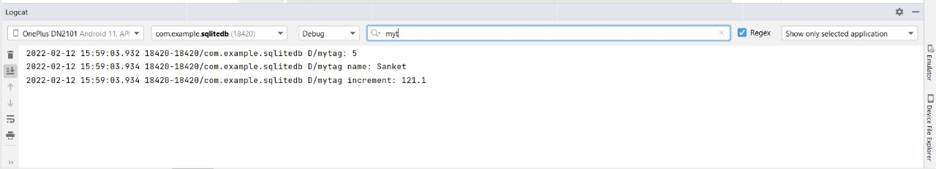

1. Write an android application using SQLite to create table and perform CRUD operations (Example. COURSE table (ID, Name, Duration, Description), perform ADD, UPDATE, DELETE and READ operations).

Ans:

Java:

**package** com.example.course24db;  
  
**import** androidx.appcompat.app.AppCompatActivity;  
  
**import** android.content.Intent;  
**import** android.os.Bundle;  
**import** android.view.View;  
**import** android.widget.Button;  
**import** android.widget.EditText;  
**import** android.widget.Toast;  
  
**public class** MainActivity **extends** AppCompatActivity {  
 EditText **id**, **name**, **drtn**, **desn**;  
 Button **saveBtn**, **lstBtn**, **showBtn**, **updateBtn**, **deleteBtn**;  
 Intent **intent**;  
 DatabaseHandler **db**;  
 String **uid**, **uname**, **udrn**, **udsn**;  
  
 @Override  
 **protected void** onCreate(Bundle savedInstanceState) {  
 **super**.onCreate(savedInstanceState);  
 setContentView(R.layout.***activity_main***);  
  
 **db** = **new** DatabaseHandler(**this**);  
 **id** = findViewById(R.id.***txtId***);  
 **name** = findViewById(R.id.***txtName***);  
 **drtn** = findViewById(R.id.***txtdrtn***);  
 **desn** = findViewById(R.id.***txtdesn***);  
  
 **saveBtn** = findViewById(R.id.***btnSave***);  
 **lstBtn** = findViewById(R.id.***btnList***);  
 **updateBtn** = findViewById(R.id.***btnUpdate***);  
 **deleteBtn** = findViewById(R.id.***btnDelete***);  
 **showBtn** = findViewById(R.id.***btnShowRec***);  
  
 *//Save record* **saveBtn**.setOnClickListener(**new** View.OnClickListener() {  
 @Override  
 **public void** onClick(View view) {  
 **uid** = **id**.getText().toString();  
 **uname** = **name**.getText().toString();  
 **udrn** = **drtn**.getText().toString();  
 **udsn** = **desn**.getText().toString();  
  
 **try** {  
 **db**.addCourse(**new** Course(Integer.*parseInt*(**uid**),**uname**,**udrn**,**udsn**));  
 Toast.*makeText*(getApplicationContext(), **"Course Added"**, Toast.***LENGTH_SHORT***).show();  
 } **catch** (Exception e) {  
 e.printStackTrace();  
 }  
 }  
 });  
 **updateBtn**.setOnClickListener(**new** View.OnClickListener() {  
 @Override  
 **public void** onClick(View v) {  
 **uid** = **id**.getText().toString();  
 **uname** = **name**.getText().toString();  
 **udrn**= **drtn**.getText().toString();  
 **udsn**=**desn**.getText().toString();  
 **try** {  
 **db**.updateCourse(**new** Course(Integer.*parseInt*(**uid**), **uname**, **udrn**,**udsn**));  
 Toast.*makeText*(getApplicationContext(), **"Course Updated"**,  
 Toast.***LENGTH_LONG***).show();  
 } **catch** (Exception e) {  
 e.printStackTrace();  
 }  
 }  
 });  
  
 **deleteBtn**.setOnClickListener(**new** View.OnClickListener() {  
 @Override  
 **public void** onClick(View v) {  
 **uid** = **id**.getText().toString();  
 **try** {  
 **db**.deleteCourse(Integer.*parseInt*(**uid**));  
 Toast.*makeText*(getApplicationContext(), **"Record Deleted"**,  
 Toast.***LENGTH_LONG***).show();  
 } **catch** (Exception e) {  
 e.printStackTrace();  
 }  
 }  
 });  
  
 *// To Display all records from table* **lstBtn**.setOnClickListener(**new** View.OnClickListener() {  
 @Override  
 **public void** onClick(View view) {  
 **intent** = **new** Intent(MainActivity.**this**, DetailsActivity.**class**);  
 startActivity(**intent**);  
 }  
 });  
  
 *// To Display a single record from table* **showBtn**.setOnClickListener(**new** View.OnClickListener() {  
 @Override  
 **public void** onClick(View view) {  
 **uid** = **id**.getText().toString();  
 **intent** = **new** Intent(MainActivity.**this**, DetailsActivity.**class**);  
 **intent**.putExtra(**"userid"**, **uid**);  
 startActivity(**intent**);  
 }  
 });  
  
 }  
}

Xml:

*<?***xml version="1.0" encoding="utf-8"***?>*<**LinearLayout xmlns:android="http://schemas.android.com/apk/res/android"  
 xmlns:app="http://schemas.android.com/apk/res-auto"  
 xmlns:tools="http://schemas.android.com/tools"  
 android:layout_width="match_parent"  
 android:layout_height="match_parent"  
 android:background="#C2F1ED"  
 android:orientation="vertical"  
 tools:context=".MainActivity"**>  
  
 <**TextView  
 android:id="@+id/Txt"  
 android:layout_width="wrap_content"  
 android:layout_height="wrap_content"  
 android:layout_marginLeft="30dp"  
 android:layout_marginTop="100dp"  
 android:fontFamily="@font/arbutus_slab"  
 android:text="Enter Course Details:"  
 android:textAlignment="center"  
 android:textSize="20sp"  
 android:textStyle="bold"** />  
  
 <**TextView  
 android:id="@+id/fstTxt"  
 android:textStyle="bold"  
 android:layout_width="wrap_content"  
 android:layout_height="wrap_content"  
 android:layout_marginLeft="30dp"  
 android:layout_marginTop="50dp"  
 android:text="ID"** />  
  
 <**EditText  
 android:id="@+id/txtId"  
 android:layout_width="wrap_content"  
 android:layout_height="wrap_content"  
 android:layout_marginLeft="30dp"  
 android:ems="10"  
 android:minHeight="48dp"  
 tools:ignore="SpeakableTextPresentCheck"** />  
  
 <**TextView  
 android:textStyle="bold"  
 android:id="@+id/secTxt"  
 android:layout_width="wrap_content"  
  
 android:layout_height="wrap_content"  
  
 android:layout_marginLeft="30dp"  
 android:text="Name"** />  
  
 <**EditText  
 android:id="@+id/txtName"  
 android:layout_width="wrap_content"  
 android:layout_height="wrap_content"  
 android:layout_marginLeft="30dp"  
 android:ems="10"  
 android:minHeight="48dp"  
 tools:ignore="SpeakableTextPresentCheck"** />  
  
 <**TextView  
 android:textStyle="bold"  
 android:id="@+id/thirdTxt"  
 android:layout_width="wrap_content"  
 android:layout_height="wrap_content"  
 android:layout_marginLeft="30dp"  
 android:text="Duration:"** />  
  
 <**EditText  
 android:id="@+id/txtdrtn"  
 android:layout_width="wrap_content"  
 android:layout_height="wrap_content"  
 android:layout_marginLeft="30dp"  
 android:ems="10"  
 android:minHeight="48dp"  
 tools:ignore="SpeakableTextPresentCheck"** />  
  
 <**TextView  
 android:textStyle="bold"  
 android:id="@+id/fourthTxt"  
 android:layout_width="wrap_content"  
 android:layout_height="wrap_content"  
 android:layout_marginLeft="30dp"  
 android:text="Description:"** />  
  
 <**EditText  
 android:id="@+id/txtdesn"  
 android:layout_width="wrap_content"  
 android:layout_height="wrap_content"  
 android:layout_marginLeft="30dp"  
 android:ems="10"  
 android:minHeight="48dp"  
 tools:ignore="SpeakableTextPresentCheck"** />  
  
 <**LinearLayout  
 android:layout_width="wrap_content"  
 android:layout_height="wrap_content"  
 android:orientation="horizontal"**>  
  
 <**Button  
 android:id="@+id/btnSave"  
 android:layout_width="wrap_content"  
 android:layout_height="wrap_content"  
 android:layout_marginLeft="10dp"  
 android:text="Save"** />  
  
 <**Button  
 android:id="@+id/btnUpdate"  
 android:layout_width="wrap_content"  
 android:layout_height="wrap_content"  
 android:layout_marginLeft="10dp"  
 android:text="Modify"** />  
  
 <**Button  
 android:id="@+id/btnDelete"  
 android:layout_width="wrap_content"  
  
 android:layout_height="wrap_content"  
 android:layout_marginLeft="10dp"  
 android:text="Delete"** />  
 </**LinearLayout**>  
  
 <**LinearLayout  
 android:layout_width="wrap_content"  
 android:layout_height="wrap_content"  
 android:orientation="horizontal"**>  
  
 <**Button  
 android:id="@+id/btnShowRec"  
 android:layout_width="wrap_content"  
 android:layout_height="wrap_content"  
 android:layout_marginLeft="10dp"  
 android:text="Show Record"** />  
  
 <**Button  
 android:id="@+id/btnList"  
 android:layout_width="wrap_content"  
 android:layout_height="wrap_content"  
 android:layout_marginLeft="10dp"  
 android:text="List all"** />  
  
 </**LinearLayout**>  
</**LinearLayout**>

Output:

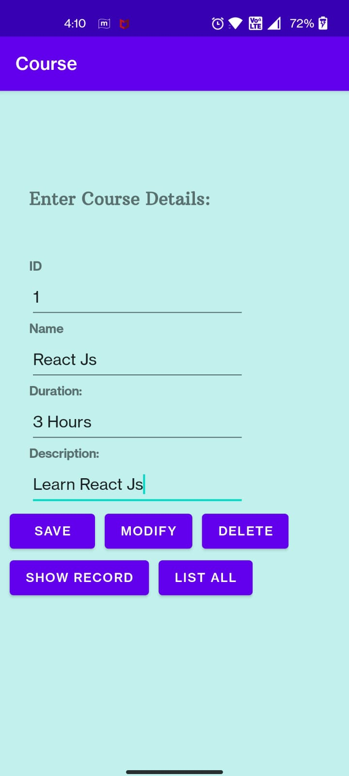

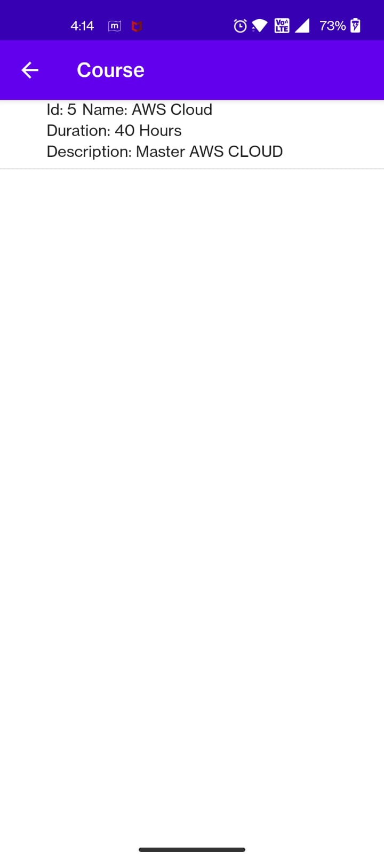

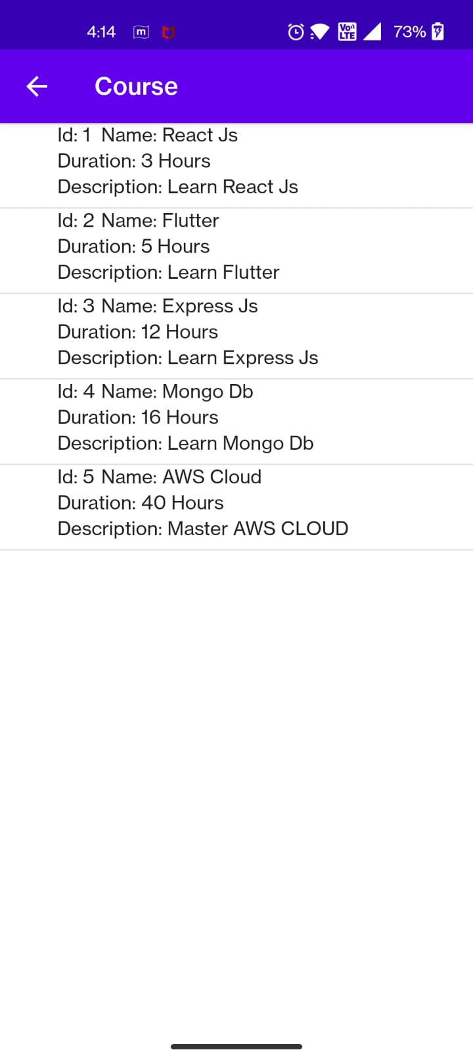

1. Write an android application using SQLite to create table and perform CRUD operations for a registration form Dance competition.

Ans:

Java:

**package** com.example.course24db;  
  
**import** android.content.Context;  
  
**import** androidx.test.platform.app.InstrumentationRegistry;  
**import** androidx.test.ext.junit.runners.AndroidJUnit4;  
  
**import** org.junit.Test;  
**import** org.junit.runner.RunWith;  
  
**import static** org.junit.Assert.*;  
  
*/**  
 * Instrumented test, which will execute on an Android device.  
 *  
 \** ***@see*** *<a href="http://d.android.com/tools/testing">Testing documentation</a>  
 */*@RunWith(AndroidJUnit4.**class**)  
**public class** ExampleInstrumentedTest {  
 @Test  
 **public void** useAppContext() {  
 *// Context of the app under test.* Context appContext = InstrumentationRegistry.*getInstrumentation*().getTargetContext();  
 *assertEquals*(**"com.example.course24db"**, appContext.getPackageName());  
 }  
}

Xml:

*<?***xml version="1.0" encoding="utf-8"***?>*<**LinearLayout xmlns:android="http://schemas.android.com/apk/res/android"  
 xmlns:app="http://schemas.android.com/apk/res-auto"  
 xmlns:tools="http://schemas.android.com/tools"  
 android:layout_width="match_parent"  
 android:layout_height="match_parent"  
 android:background="#C2F1ED"  
 android:orientation="vertical"  
 tools:context="com.example.dancedb.MainActivity"**>  
  
 <**TextView  
 android:id="@+id/Txt"  
 android:layout_width="wrap_content"  
 android:layout_height="wrap_content"  
 android:layout_marginLeft="30dp"  
 android:layout_marginTop="100dp"  
 android:fontFamily="@font/arbutus_slab"  
 android:text="Dance Competetion Details:"  
 android:textAlignment="center"  
 android:textSize="20sp"  
 android:textStyle="bold"** />  
  
 <**TextView  
 android:id="@+id/fstTxt"  
 android:textStyle="bold"  
 android:layout_width="wrap_content"  
 android:layout_height="wrap_content"  
 android:layout_marginLeft="30dp"  
 android:layout_marginTop="50dp"  
 android:text="ID"** />  
  
 <**EditText  
 android:id="@+id/txtId"  
 android:layout_width="wrap_content"  
 android:layout_height="wrap_content"  
 android:layout_marginLeft="30dp"  
 android:ems="10"  
 android:minHeight="48dp"  
 tools:ignore="SpeakableTextPresentCheck"** />  
  
 <**TextView  
 android:textStyle="bold"  
 android:id="@+id/secTxt"  
 android:layout_width="wrap_content"  
  
 android:layout_height="wrap_content"  
  
 android:layout_marginLeft="30dp"  
 android:text="Name"** />  
  
 <**EditText  
 android:id="@+id/txtName"  
 android:layout_width="wrap_content"  
 android:layout_height="wrap_content"  
 android:layout_marginLeft="30dp"  
 android:ems="10"  
 android:minHeight="48dp"  
 tools:ignore="SpeakableTextPresentCheck"** />  
  
 <**TextView  
 android:id="@+id/thirdTxt"  
 android:layout_width="wrap_content"  
 android:layout_height="wrap_content"  
 android:layout_marginLeft="30dp"  
 android:text="Mobile Number:"  
 android:textStyle="bold"** />  
  
 <**EditText  
 android:id="@+id/txtdrtn"  
 android:layout_width="wrap_content"  
 android:layout_height="wrap_content"  
 android:layout_marginLeft="30dp"  
 android:ems="10"  
 android:inputType="phone"  
 android:minHeight="48dp"  
 tools:ignore="SpeakableTextPresentCheck"** />  
  
 <**TextView  
 android:id="@+id/fourthTxt"  
 android:layout_width="wrap_content"  
 android:layout_height="wrap_content"  
 android:layout_marginLeft="30dp"  
 android:text="Dance Type:"  
 android:textStyle="bold"** />  
  
 <**Spinner  
 android:id="@+id/spinner2"  
 android:layout_width="215dp"  
 android:layout_height="48dp"  
 android:layout_marginLeft="30dp"** />  
  
 <**LinearLayout  
 android:layout_width="wrap_content"  
 android:layout_height="wrap_content"  
 android:orientation="horizontal"  
 android:layout_marginStart="30dp"**>  
  
 <**Button  
 android:id="@+id/btnSave"  
 android:layout_width="wrap_content"  
 android:layout_height="wrap_content"  
 android:layout_marginLeft="10dp"  
 android:text="Save"** />  
  
 <**Button  
 android:id="@+id/btnUpdate"  
 android:layout_width="wrap_content"  
 android:layout_height="wrap_content"  
 android:layout_marginLeft="10dp"  
 android:text="Modify"** />  
  
 <**Button  
 android:id="@+id/btnDelete"  
 android:layout_width="wrap_content"  
  
 android:layout_height="wrap_content"  
 android:layout_marginStart="10dp"  
 android:text="Delete"** />  
 </**LinearLayout**>  
  
 <**LinearLayout  
 android:layout_width="wrap_content"  
 android:layout_height="wrap_content"  
 android:orientation="horizontal"  
 android:layout_marginStart="30dp"**>  
  
 <**Button  
 android:id="@+id/btnShowRec"  
 android:layout_width="wrap_content"  
 android:layout_height="wrap_content"  
 android:layout_marginLeft="10dp"  
 android:text="Show Record"** />  
  
 <**Button  
 android:id="@+id/btnList"  
 android:layout_width="wrap_content"  
 android:layout_height="wrap_content"  
 android:layout_marginLeft="10dp"  
 android:text="List all"** />  
  
 </**LinearLayout**>  
  
</**LinearLayout**>

DetailsXml:

*<?***xml version="1.0" encoding="utf-8"***?>*<**LinearLayout xmlns:android="http://schemas.android.com/apk/res/android"  
  
 xmlns:tools="http://schemas.android.com/tools"  
 android:id="@+id/linearLayout"  
 android:layout_width="match_parent"  
 android:layout_height="match_parent"  
 android:orientation="vertical"  
 tools:context="com.example.dancedb.DetailsActivity"**>  
  
  
 <**ListView  
 android:id="@+id/user_list"  
 android:layout_width="match_parent"  
 android:layout_height="match_parent"  
 android:dividerHeight="1dp"  
  
 android:scrollbars="vertical"**/>  
  
</**LinearLayout**>

Output:

